Infineon MFP Build-Book

- confidential -

Status: Final

Dokumentversion: 3.4

Date: 04-May-2020

Author: RICOH Deutschland GmbH

Verfasser des Dokuments: Projektteam „Office 2010 BÜ“

|  |  |  |  |  |
| --- | --- | --- | --- | --- |
| **Document History**  (Log is for information only and should not be used as an escalation point.) | | | | |
| Ver | Item | Name | Date | Notes |
| 1.0 | Created by | Jan Sorgenfrey | 08-Apr-2016 | First release |
| 1.1 | Edited by | Jan Sorgenfrey | 11-Oct-2016 | Card reader:   * Changed pictures of MP C306ZSP and MP C401SP * add MP C3004SP and MP C3504SP |
| 1.2 | Edited by | Jan Sorgenfrey | 09-Jan-2017 | * Service Label placement * Add 307ZSP |
| 1.3 | Updated by | Jens Reimann | 01-Nov-2018 | * Check and renew of settings * Add new devices |
| 2.0 | Update & Review | Jens Reimann | 21-Nov-2018 | * GB Ver. Information; Adv. * Add SNMP Trap DMNX |
| 2.1 | Update by | Christian Lang / Jens Reimann | 13-Jun-2019 | * Add Home Key Setting * Add Back Key Setting * Add Models 5.1 Mount Card Reader * Add SDK/FW Version |
| 2.2 | Update by | Christian Lang | 24-Jun-2019 | * DOSS and HD Encryption |
| 2.3 | Update by | Christian Lang | 01-Jul-2019 | * Update contact persons section 7 |
| 2.4 | Update by | Christian Lang  Jens Reimann | 04-Jul-2019 | * Change screenshot GeniusMFP Setting |
| 2.5 | Draft | Christian Lang | 19-Nov-2019 | * Change of responsibilities |
| 2.6 | Draft | Christian Lang | 10-Feb-2020 | * Add IMC300/400 * Add note:  SiteCertificats = Root certificats * Add Setup of Function Priority (SOP Devices IMC Series) * Add DOSS and HD Encryption (IMC Series) |
| 2.7 | Draft | Christian Lang | 20-Feb-2020 | * Change screenshots section 3.1 |
| 2.8 | Draft | Christian Lang | 11-Mrz-2020 | * Comments update |
| 2.9 | Draft | Christian Lang | 17-Mrz-2020 | * Add 1.1 Responsibility |

|  |  |  |  |  |
| --- | --- | --- | --- | --- |
| 3.0 | Draft | Jens Reimann / Christian Lang | 26-Mrz-2020 | * Change of certificate description section 1 / 4.1 and 4.2 * Final approved |
| 3.1 | Draft | Jens Reimann / Christian Lang | 08-Apr-2020 | * Delete Java Install settings - section 2 * Delete “Infineon Gemstar Project Side\*” - section 3 * Add Reference to the GB manual – section 3 * Change to GB SOP Client – section 5.1 |
| 3.2 | Draft | Jens Reimann/ Christian Lang | 23-Apr-2020 | * Delete “Ricoh Global Delivery Manager” – section 8/9/10 * Add old certificate description section 1 / 4.1 and 4.2 * Add section 10 “Remote Panel Operation” * Add section 14 “Screen Startup Mode” * Add section 15 “Setup of Card Reader IMC” |
| 3.3 | Final | Christian Lang | 04-May-2020 | * Add section 16 “Screen Device Always-Connection Setting” |
| 3.4 | Final | Christian Lang | 04-Jun-2020 | * Change Responsibility section 7 “Import of Device specific Certificates” * Add new ACT menu section 14/15 |
| 3.5 | Final | Christian Lang | 24.06.2020 | * Add Section 17 Enhanced External Charge Unit Management |
| 3.6 | Final | Christian Lang | 24.02.2022 | * Change Responsibility section 6 “Service Label” * Change IMC 400 -> IMC400/400F |

Content

[1 Introduction 6](#_Toc43901719)

[1.1 Responsibility 7](#_Toc43901720)

[2 Preparing of the MFP 8](#_Toc43901721)

[3 Genius MFP-Client Installation and Configuration 8](#_Toc43901722)

[3.1 Installation of xlet and servlet 8](#_Toc43901723)

[3.2 Configuration of Genius MFP-Client 10](#_Toc43901724)

[4 Import of Site Certificates 12](#_Toc43901725)

[4.1 Import on Ricoh MFP – via Web Image Monitor 12](#_Toc43901726)

[4.2 Check (Import) Site Certificates in Genius MFP-Client 14](#_Toc43901727)

[5 Installation of Card Reader 17](#_Toc43901728)

[5.1 Mount card reader at MFP 17](#_Toc43901729)

[5.2 Configuration of card reader 18](#_Toc43901730)

[6 Service Label Placement 19](#_Toc43901731)

[7 Import of Device specific Certificates 20](#_Toc43901732)

[8 Setup of Function Priority (SOP Devices) 23](#_Toc43901733)

[9 Setup of Function Priority (SOP Devices IMC Series) 25](#_Toc43901734)

[10 Setup of Remote Panel Operation (SOP Devices IMC Series) 29](#_Toc43901735)

[11 Setup of Home Key Application Setting (SOP Devices / SOP Devices IMC Series) 30](#_Toc43901736)

[12 Setup of Back Key Setting (SOP Devices) 32](#_Toc43901737)

[13 Setup of Back Key Setting (SOP Devices IMC Series) 32](#_Toc43901738)

[14 Setup of Screen Startup Mode (SOP Devices IMC Series) 32](#_Toc43901739)

[15 Setup of Card Reader (SOP Devices IMC Series) 32](#_Toc43901740)

[16 Screen Device Always-Connection Setting (SOP Devices IMC Series) 33](#_Toc43901741)

[17 Enhanced External Charge Unit Management 33](#_Toc43901742)

[18 DOSS and HD Encryption 33](#_Toc43901743)

[19 DOSS and HD Encryption (IMC Series) 34](#_Toc43901744)

[20 Complete Device Configuration 35](#_Toc43901745)

[21 Appendix 35](#_Toc43901746)

[21.1 SDK-J & Firmware requirement 35](#_Toc43901747)

[21.1.1 Minimum Version of SDK-J 35](#_Toc43901748)

[21.1.2 Minimum Version of Firmware 35](#_Toc43901749)

# Introduction

The following graphic shows needed components and steps for configuration of Ricoh device for Infineon global environment. Details defined in the points below.

***Please note:***

* The inserted images are essentially only for illustrative purposes of the required steps.
* Version information shown in the images does not necessarily correspond to the current and latest Version.
* Please ask always the IFX Contact and for the infrastructure details on the target location (802.1x activated yes / no etc.)



## Responsibility

Changes in responsibilities with the beginning of the new contract Q2/2020.

|  |  |  |
| --- | --- | --- |
| Section | **Customer or his service provider**  **(Section in green)** | **Pre-installation Ricoh (Section in blue)** |
| 2. Preparing of the MFP |  | **X** |
| 3. Genius MFP-Client Installation and Configuration | **X** |  |
| 4.1. Import on Ricoh MFP – via Web Image Monitor |  | **X** |
| 4.2. Check (Import) Site Certificates in Genius MFP-Client | **X** |  |
| 5. Installation of Card Reader |  | **X** |
| 6. Service Label Placement | **X** |  |
| 7. Import of Device specific Certificates | **X** |  |
| 8. Setup of Function Priority (SOP Devices) | **X** |  |
| 9. Setup of Function Priority (SOP Devices IMC Series) | **X** |  |
| 10. Setup of Remote Panel Operation |  | **X** |
| 11. Setup of Home Key Application Setting  (SOP Devices / SOP Devices IMC Series) | **X** |  |
| 12. Setup of Back Key Setting (SOP Devices) |  | **X** |
| 13. Setup of Back Key Setting (SOP Devices IMC Series) |  | **X** |
| 14.Setup of Screen Startup Mode (SOP Devices IMC Series) |  | **X** |
| 15. Setup of Card Reader (SOP Devices IMC Series) |  | **X** |
| 16.Screen Device Always-Connection Setting (SOP Devices IMC Series) |  | **X** |
| 17. Enhanced External Charge Unit Management |  | **X** |
| 18. DOSS and HD Encryption |  | **X** |
| 19. DOSS and HD Encryption (IMC Series) |  | **X** |

# Preparing of the MFP

Before you start the Genius MFP-Client installation, please check that all needed equipment is available on site and relevant certificates / software is accessible for you.

# Genius MFP-Client Installation and Configuration

**Prerequisites:**

1. You have a ready laptop, MFP, and a router or switch, each must connected to form a closed network. Your laptop and MFP must **not** be connected to the Infineon network, they must be connected in a closed network.
2. Have latest version of xlet & servlet
3. You must have the “Main phoenix service URL” for specific Infineon site – has to be provided by Infineon during order process

***Further information for GB SOP installation can be found in the Genius Byte MFP Client manual! (GeniusMFP\_RicohSmartSDK\_Client\_2.20.1.0\_Manual.pdf)***

## Installation of xlet and servlet

**Establish connection to MFP:**

1. Open Web Browser
2. Type http://[MFP IP] address (open web image monitor)
3. Login as admin.
4. Click the **[Configuration]** link.
5. Click the **[Install]** link to access installation screen.  
   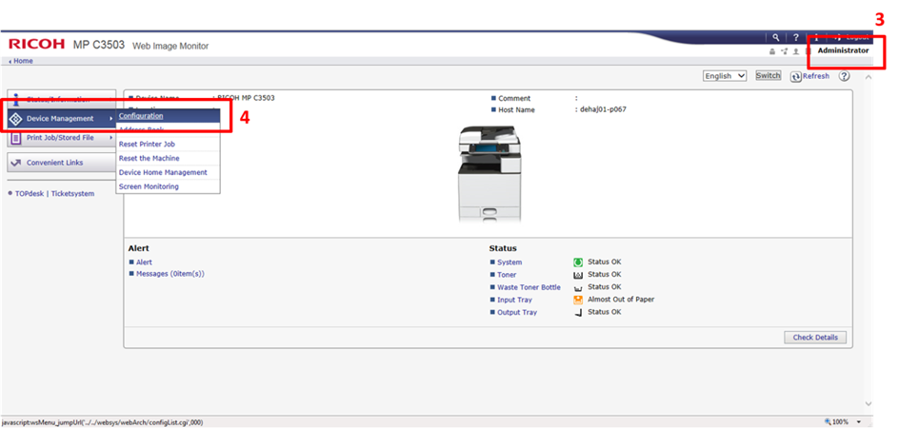

**Installation procedure:**

1. Select **[Local File]**
2. Click the **[Browse]** button and select the the zip-file you would like to install
   1. servlet
   2. xlet
3. Click the **[Display Extended Feature List]** button   
   *(the File will be loaded – take some time)*

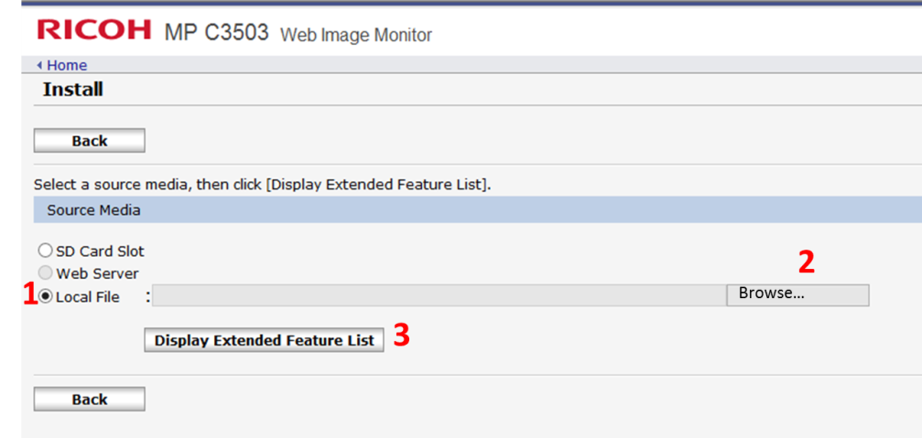

1. Select “**Flash Memory / SD2 (newer devices)**” for **[Install to]**
2. Select “**On**” for **[Auto Start]**
3. Select “**Genius MFP…**”
4. Click the **[Install]** button
5. Click the **[OK]** button to start Installation (Take some time)

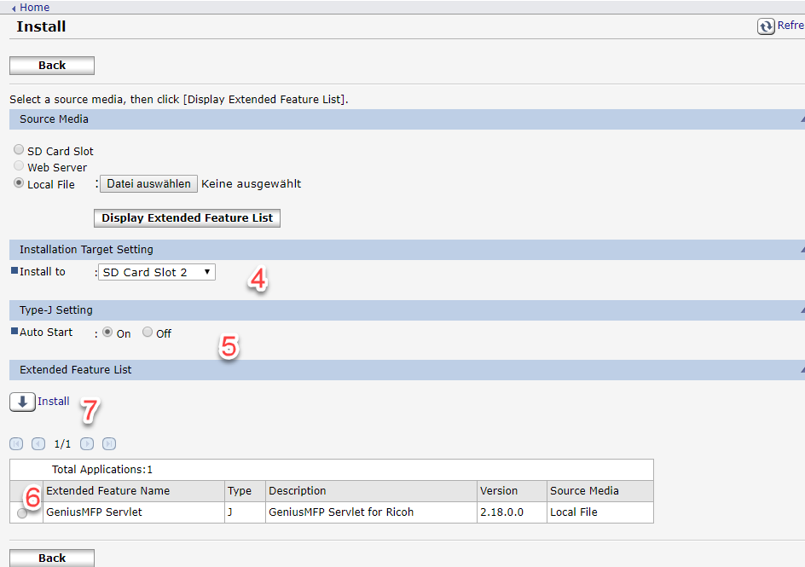

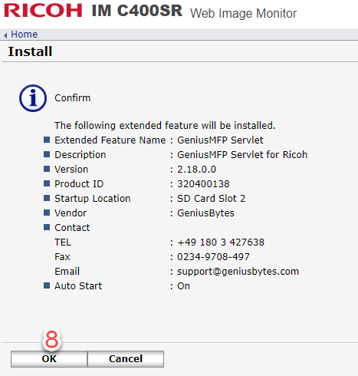

Repeat from Step 1 through 8 to **install second component** (servlet **and** xlet have to be imported and installed) of Genius MFP-Client. (GB Version 11.2018 = v2.18)

## Configuration of Genius MFP-Client

1. Open Web Browser
2. Type http://[MFP IP]:8080/mymfp/conf address (open Genius MFP Client )  
   Note: extended feature has to be started (WIM🡪 Extended Feature Info)
3. Login as admin (username: admin / password: admin)  
   ***Note:*** *After the first connection to the Genius Bytes Server the Infineon MFP-Password is applied*
4. Click the **[Settings]** link

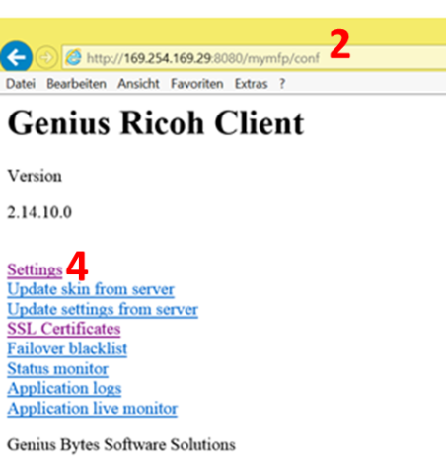

1. Activate **[Update settings at application start]**
2. Activate **[Update skin at application start]**
3. Adjust **[Main phoenix service URL or GeniusCDDS Server URL]** –<http://printq1:8080/server/rest> )
4. Click **[Submit]** button

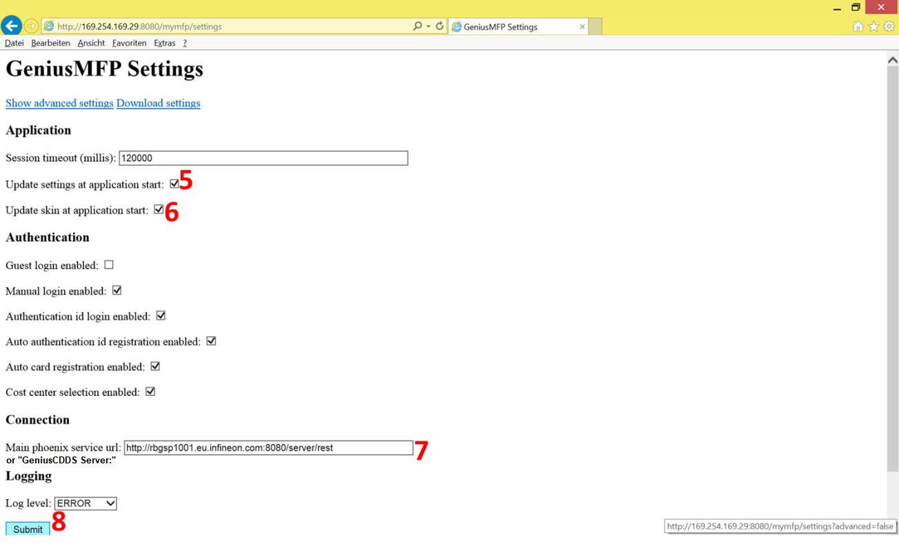

# Import of Site Certificates

**Prerequisites:**

1. You have a ready laptop, MFP, and a router or switch, each must connected to form a closed network. Your laptop and MFP must **not** be connected to the Infineon network, they must be connected in a closed network.
2. Have latest version of site certificates (path of provision: Ricoh Germany 🡪 Ricoh Global Services 🡪 Ricoh Local Supplier Company 🡪 local pre-configuration department / technician)
   1. infineon technologies ag phone ca 2.cer
   2. infineon technologies ag root ca 2.cer
   3. infineon technologies ag device ca 3.cer
   4. infineon technologies ag root ca 3.cer

## Import on Ricoh MFP – via Web Image Monitor

**Establish connection to MFP:**

1. Open Web Browser
2. Type http://[MFP IP] address (open web image monitor)
3. Login as admin.
4. Click the **[Configuration]** link.
5. Click the **[Site Certificates or Root Certificate (on new models)]** link to access site certificate screen.



1. Select “Active” for **[Site Certificate or Root Certificate Check]**
2. Click **[Browse]** button
3. Select first site certificate you would like to import
4. Click **[OK]** button
5. Click **[Import]** button.

Repeat from Step 7 through 10 to import **second site or root certificates** (booth site certificates must be imported / installed) on Ricoh MFP.

***Important note:   
The menu item was changed for newer devices - Site Certificats = Root Certificates***

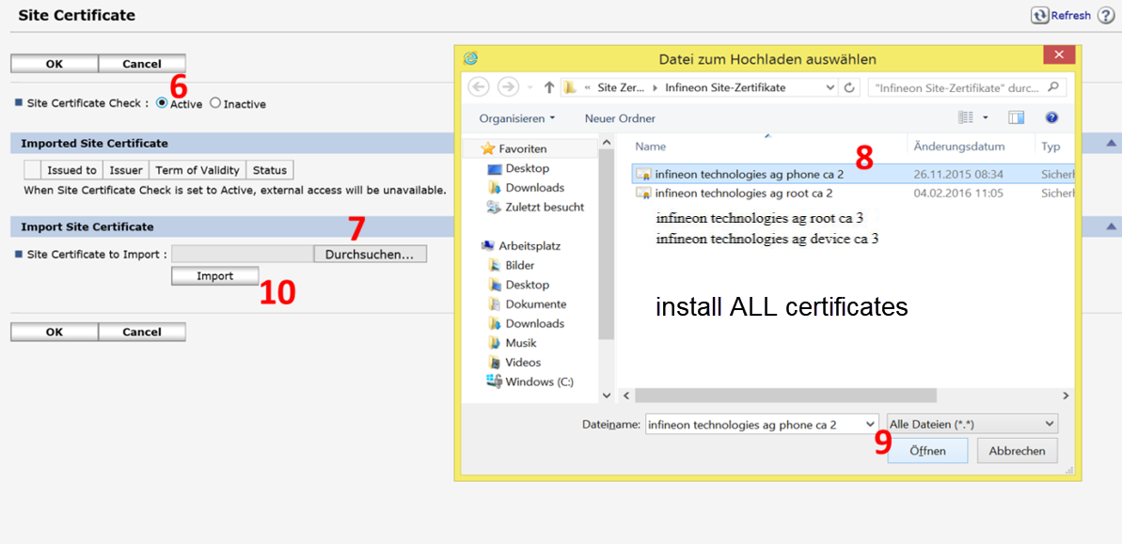

Repeat from Step 7 through 10 to **import second site or root certificates** (booth site certificates must imported and installed) on the MFP.

1. Click **[OK]** button

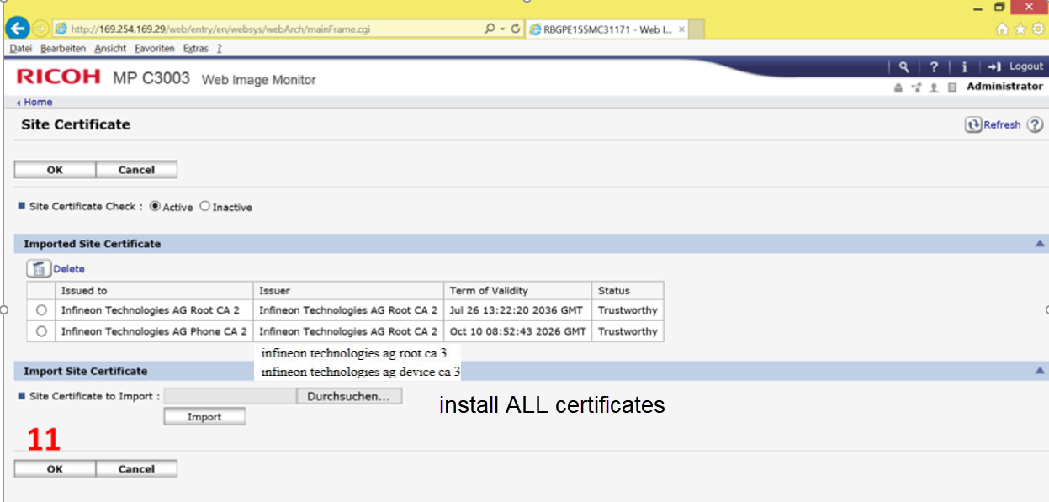

## Check (Import) Site Certificates in Genius MFP-Client

Note: Normally the site certificates automatically installed during installation procedure of servlet and xlet. Therefore, please find below step-by-step instruction to check if site certificates are imported automatically on Genius MFP-Client

**Check of site certificates in Genius MFP-Client:**

1. Open Web Browser
2. Type http://[MFP IP]:8080/mymfp/conf address (open Genius MFP Client )  
   Note: extended feature has to be started (WIM🡪 Extended Feature Info)
3. Login as admin
   1. username: admin
   2. password: admin

***Note:*** *After the first connection to the Genius Bytes Server the Infineon MFP-Password is applied*

1. Click the **[SSL Certificates]** link

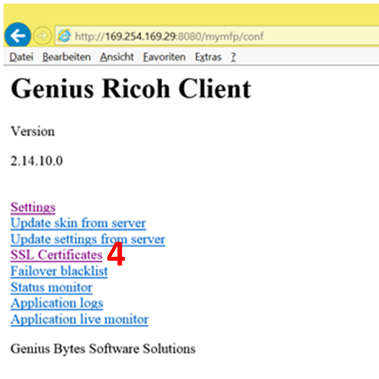

1. Check if booth site certificates are imported correctly
   1. Yes: You can log out
   2. No: Proceed with Instructions (Import of site certificates in Genius MFP-Client)

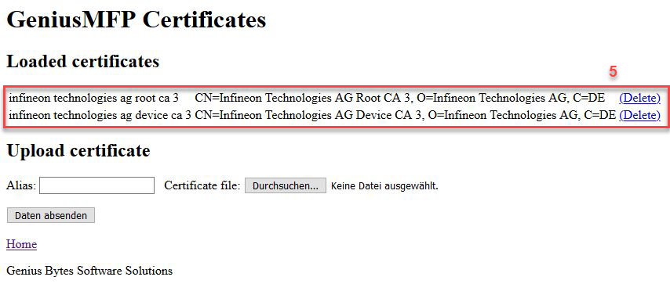

**Import of site certificates in Genius MFP-Client:**

1. Open Web Browser
2. Type http://[MFP IP]:8080/mymfp/conf address (open Genius MFP Client )  
   Note: extended feature has to be started (WIM🡪 Extended Feature Info)
3. Login as admin
   1. username: admin
   2. password: admin  
      ***Note:*** *After the first connection to the Genius Bytes Server the Infineon MFP-Password is applied*
4. Click the **[SSL Certificates]** link



1. Click the **[Browse]** link
2. Select first site certificate you would like to import
3. You have to enter “Alias name” of site certificate at step 9: **Copy** Alias name
4. Click **[Open]** button
5. Enter Alias name of chosen site certificate
6. Click **[Submit]** button

Repeat from Step 6 through 10 to **import site certificates** (all site certificates must be imported / installed) on Ricoh MFP.

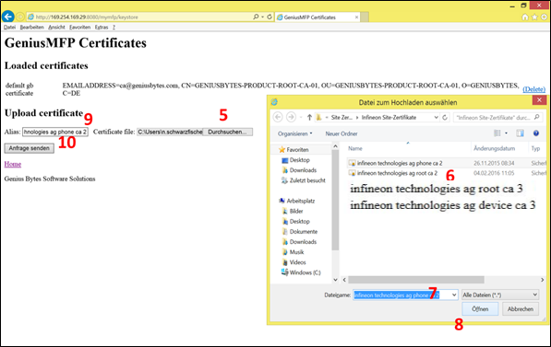

# Installation of Card Reader

**Prerequisites:**

1. You have a ready laptop and card reader.
2. Have latest version of customer specific firmware-, configuration- , digest file for Inepro Card Reader and Inepro usbreaderupdate.exe (path of provision: Ricoh Germany 🡪 Ricoh Global Services 🡪 Ricoh Local Supplier Company 🡪 local pre-configuration department / technician)
3. You need cable channel or cable clamps to fix the cable at the MFP.

## Mount card reader at MFP

|  |  |  |
| --- | --- | --- |
| **MP C3003SP/MP C3503SP**  **MP C3004SP/MP C3504SP**  **IM C20/25/30/35/40/45/55 & 6000** | **MP C401SP** | **MP C306ZSP**  **MP C307ZSP IM C300/400/400F** |
|  |  |  |
| Place card reader right of panel in the “smard card reader interface” (cable routing should be inside of MFP) - for further details “how to build in”, see official service manual of model | Place card reader inside of the feeder - (cable routing should be inside of MFP) – for further details “how to build in”, see official service manual of model | Place card reader in prepared build in place behind panel – (cable routing should be inside of MFP) - for further details “how to build in”, see official service manual of model |

**Important note:**

Genius Byte Java SDK Client:   
- Card reader must be connected to the GW Controller  
  
Genius Byte SOP Client (since 04/2020):   
- Card reader must be connected to the SOP Panel

## Configuration of card reader

Note: **[usb\_multiiso\_41.0.1120.digest]** have to be in same folder like firmware.

1. Connect Card Reader via USB to Laptop
2. Start **[usbreaderupdate.exe]**
3. Click **[Switch to program mode]** button
4. Click **[…]** button and select firmware-file
5. Click **[Program firmware]** button (take some time shown by Status)
6. Click **[…]** button and select config-file
7. Click **[Program config]** button (take some time shown by Status)
8. Click **[Switch to normal mode]** button

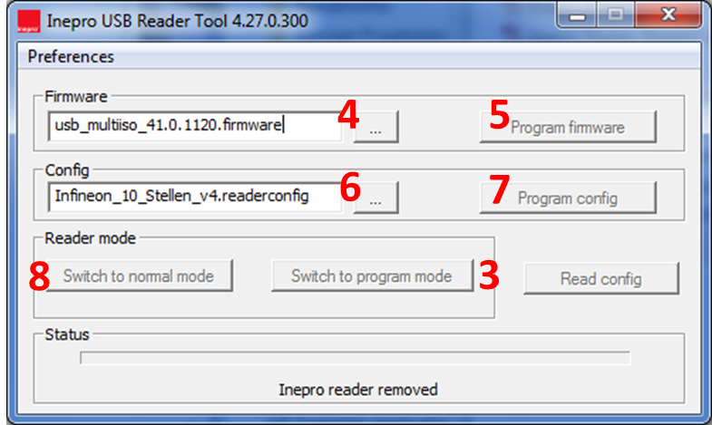

# Service Label Placement

Use provided templates at Gemstar Infineon Project Site in combination with provided site acronyms out of order request by Infineon for creation of service label. The package at Gemstar contains a merge data file and the corresponding merge document. Moreover the required barcode-font and an additional explanation is enclosed. If needed the merge document could be filled out manually.

Placement:

* Top left at front door / cover
* No other service label should be visible

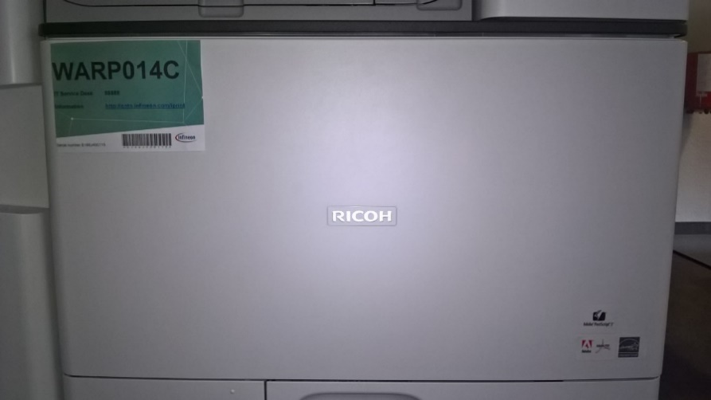

**Change Oct 20:**   
Customer attaches the service labels himself !

# Import of Device specific Certificates

The device individual certificates is created on the base of the agreed hostname of each device, which consist of site acronym + P + serial number - e.g. RBG for Regensburg, V1234567890 creates “RBGPV1234567890” as hostname.

Therefore, minimum three working days before delivery the serial number and MAC-Address must provided to Infineon:

1. Infineon site rollout coordinator **AND**
2. Michael.fritz@infineon.com **AND**
3. Markus.leikam@infineon.com **AND**
4. support@sandata.de

**Preparations:**

1. certificates are generated **by Infineon** (provided on same server like DMNX-E by Infineon site rollout coordinator)
2. establish network connection with device and access to web image monitor of device by browsing hostname in web-browser
3. log-in as admin
4. select device management 🡪 configuration
5. select device certificate

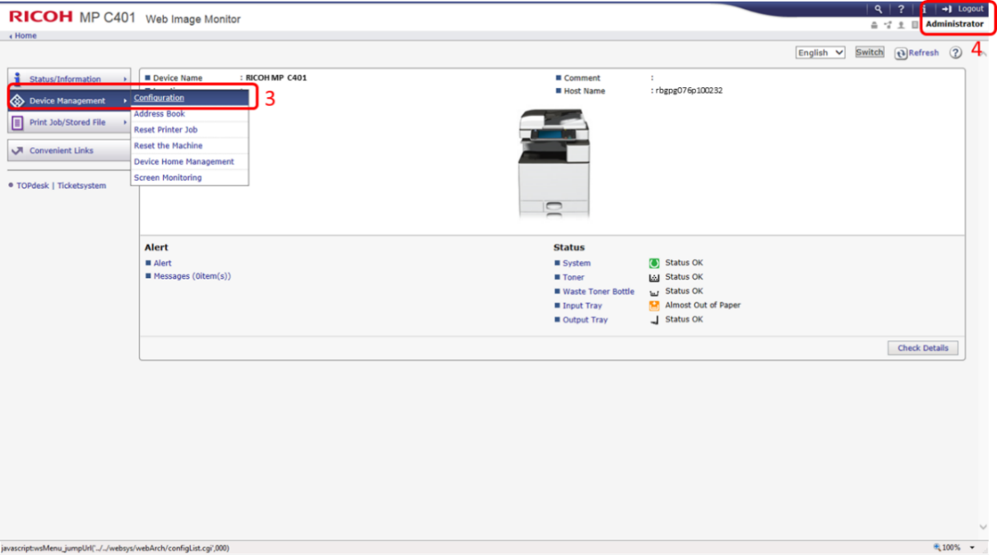

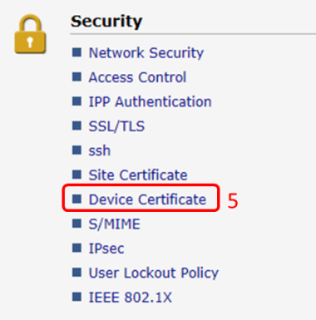

**Upload Device Certificate for SSL and 802.1x**

***Please take care that 802.1x is on use at the target location.***

1. 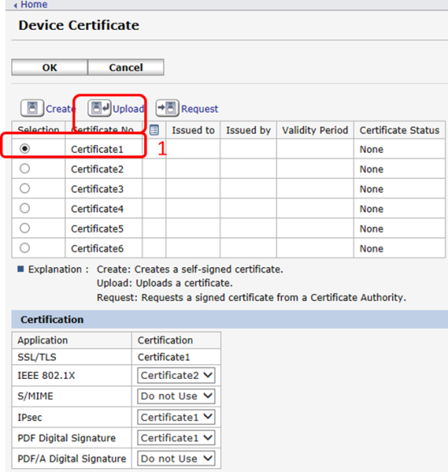select certificate slot 1 and click upload
2. select PKCS #12
3. browse file (**.pfx**)
4. enter password (default: 123)
5. click upload (upload takes time)
6. change certificate slot for 802.1x to certificate 1
7. confirm with OK

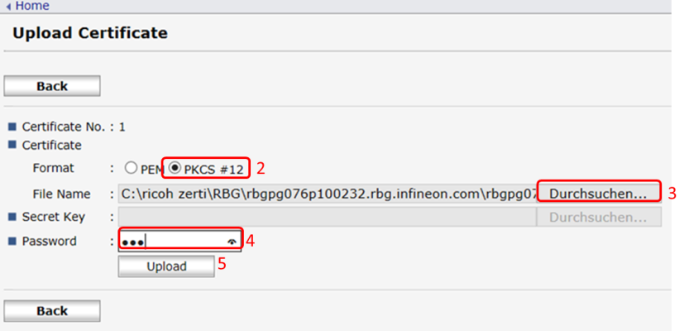

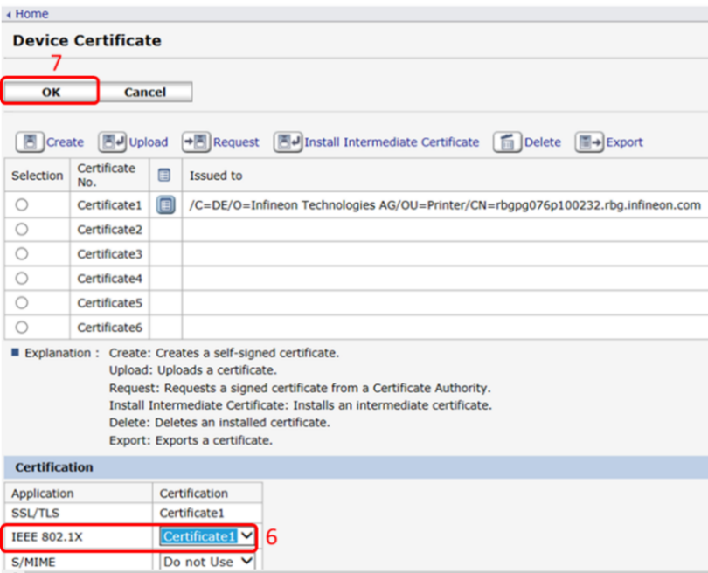

**Configuration 802.1x and activating 802.1x:**

1. 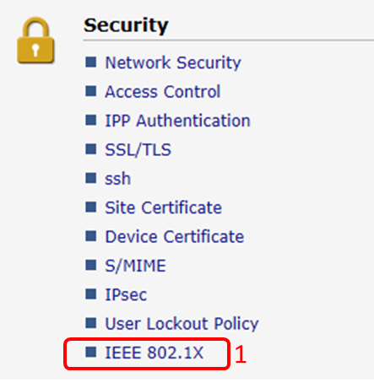select IEEE 802.1x
2. if not done enter hostname of device
3. confirm with OK

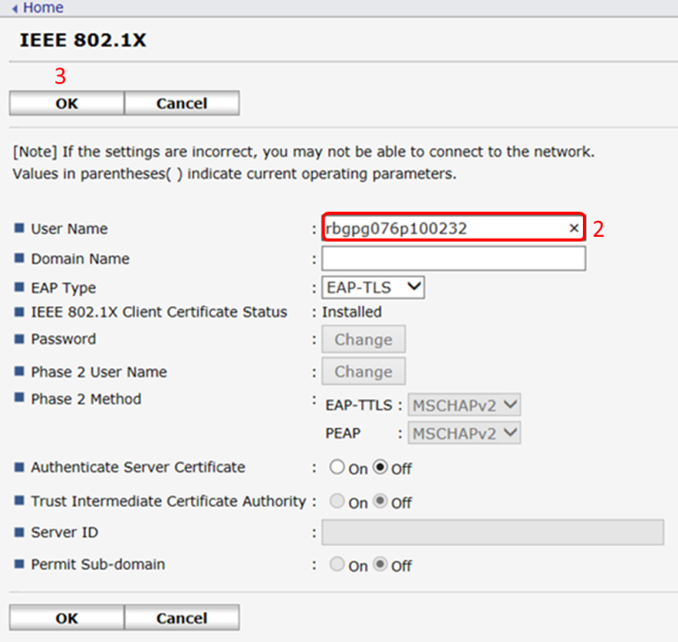

# Setup of Function Priority (SOP Devices)

To setup the Genius Bytes application as priority function on SOP devices you must change the settings on the device. On small locations with a small amount of devices to rollout you can setup the device priority function over the display of the device as follow.

*For larger rollouts / mass settings, ask your local Infineon contact to assist with automated device settings over the Service Provider SanData in Germany / Austria.*

**Manual setup of function priority to Genius Bytes MFP Client**

1. Login as Device Administrator.
2. after Login, select „User Tools“.

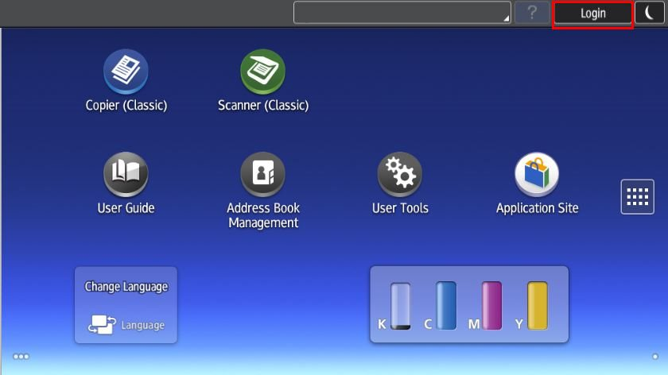

**1**

**2**

1. select „Screen Features“

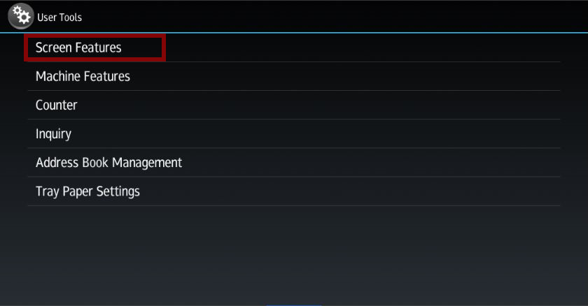

1. select „Screen Device Settings“.

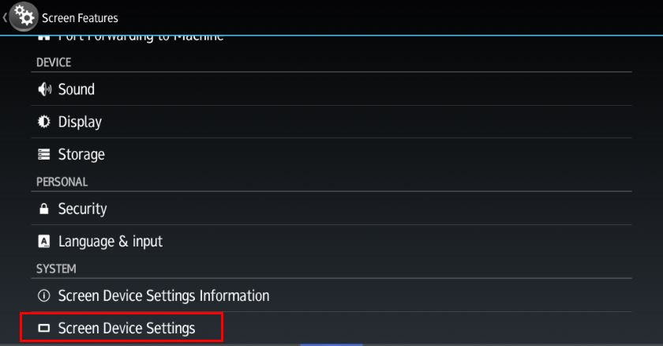

1. select „Function Priority“.

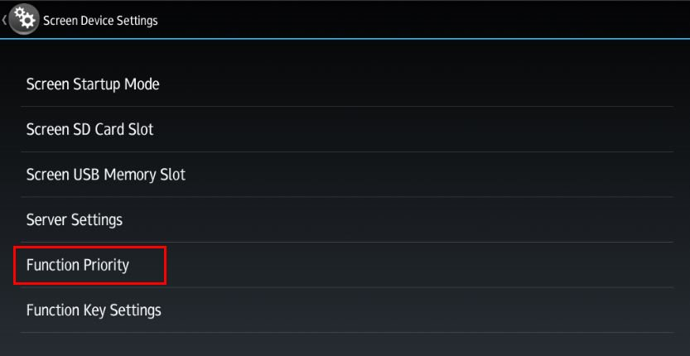

1. choose „GeniusMFP“ as Function Priority

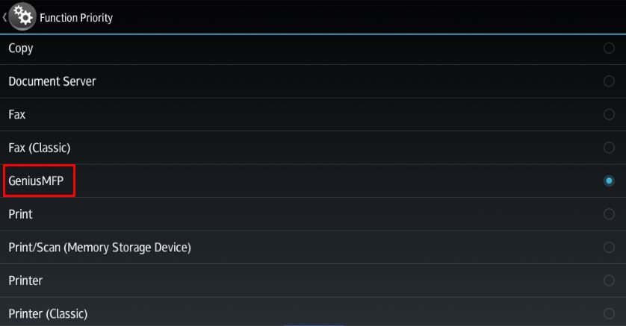

1. go back and logout.

# Setup of Function Priority (SOP Devices IMC Series)

To setup the Genius Bytes application as priority function on SOP devices you must change the settings on the device. On small locations with a small amount of devices to rollout you can setup the device priority function over the display of the device as follow.

*For larger rollouts / mass settings, ask your local Infineon contact to assist with automated device settings over the Service Provider SanData in Germany / Austria.*

**Manual setup of function priority to Genius Bytes MFP Client**

1. Login as Device Administrator.
2. after Login, select „Settings“.

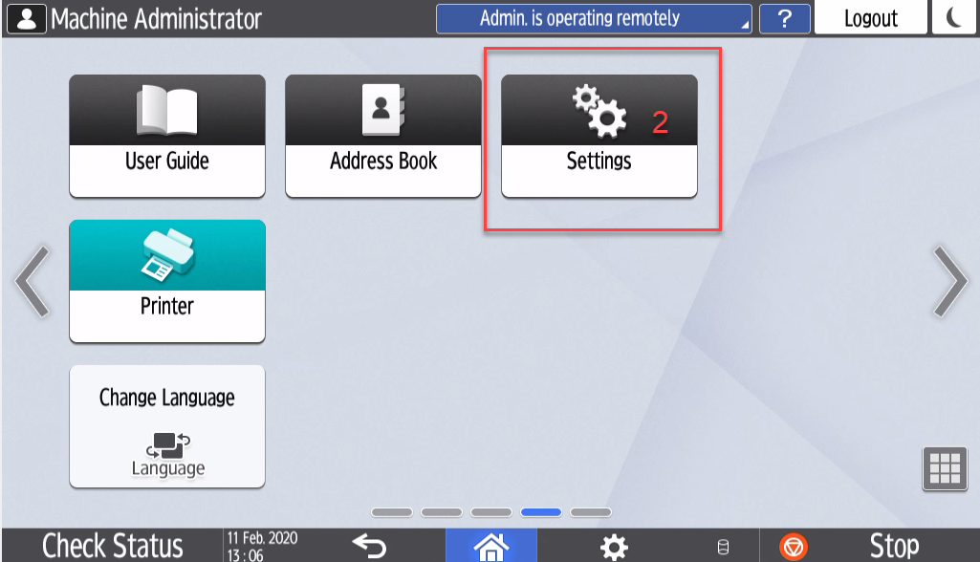

1. select „System Settings“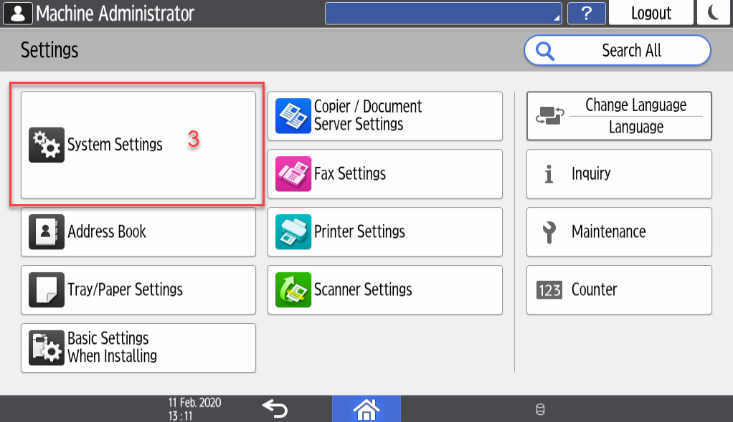
2. select „Display/Input/Display“.

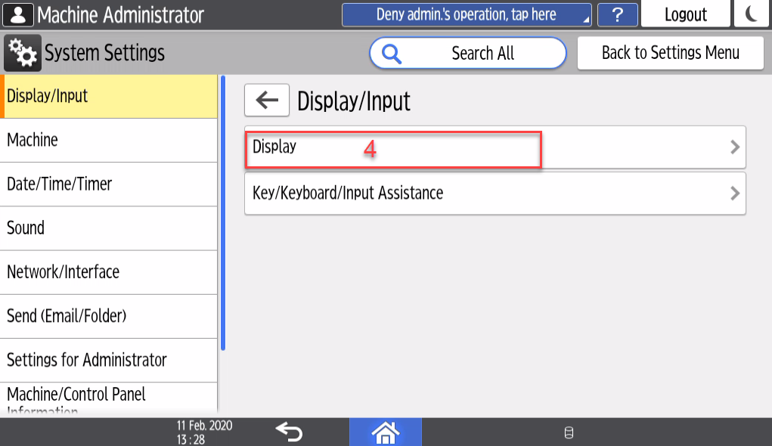

1. select „Function Priority“.

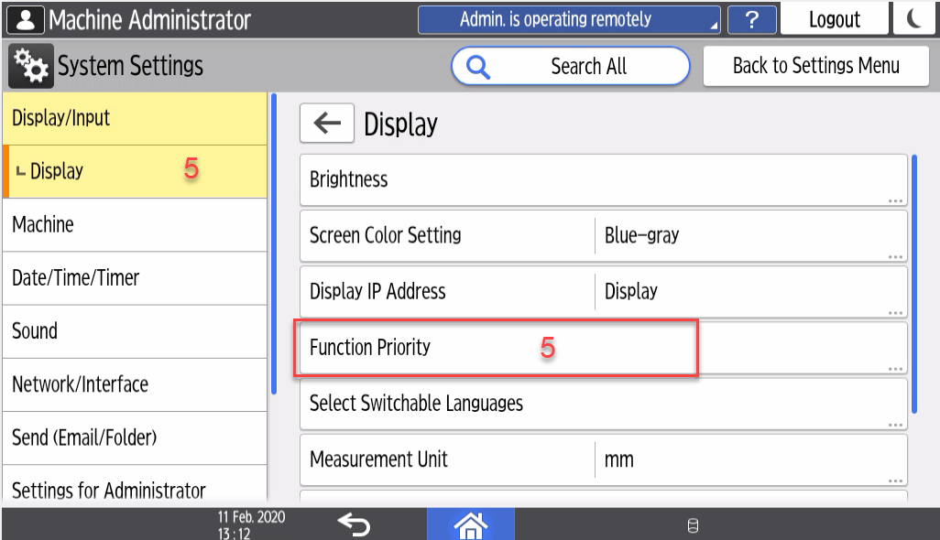

1. choose „Home“.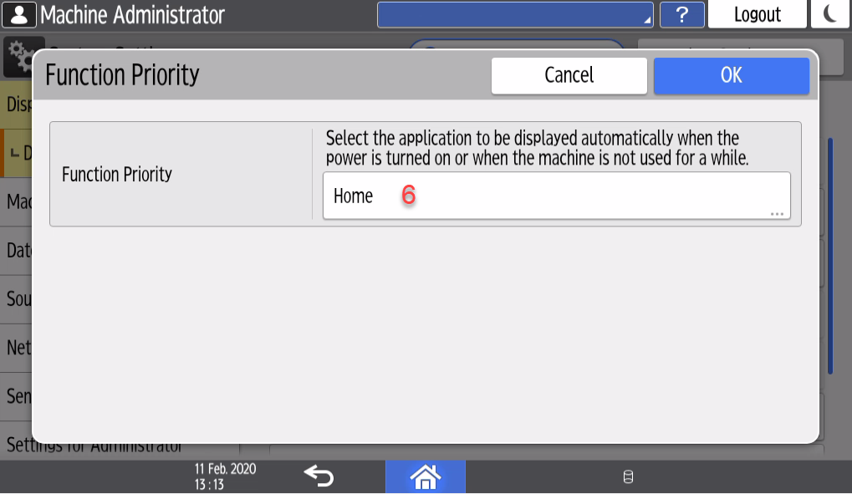
2. choose „GeniusMFP“ as Function Priority 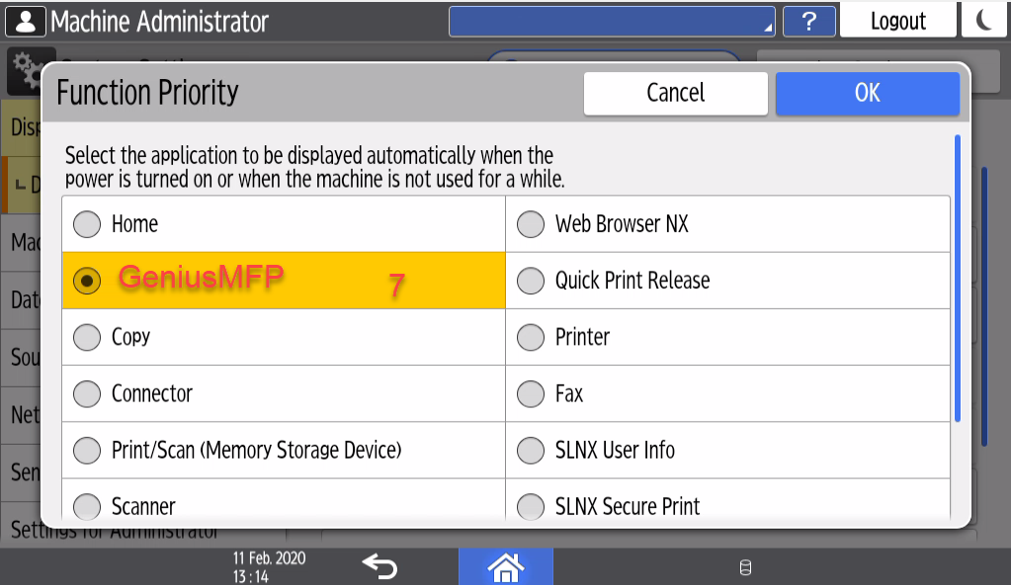
3. go back and logout.

# Setup of Remote Panel Operation (SOP Devices IMC Series)

1. Login as Device Administrator.
2. after Login, select „Settings“.
3. select „System Settings“.
4. select „Settings for Adminstrator“.
5. select „Remote Panel Operation“.
6. choose „Active“.
7. choose „OK“
8. go back and logout.



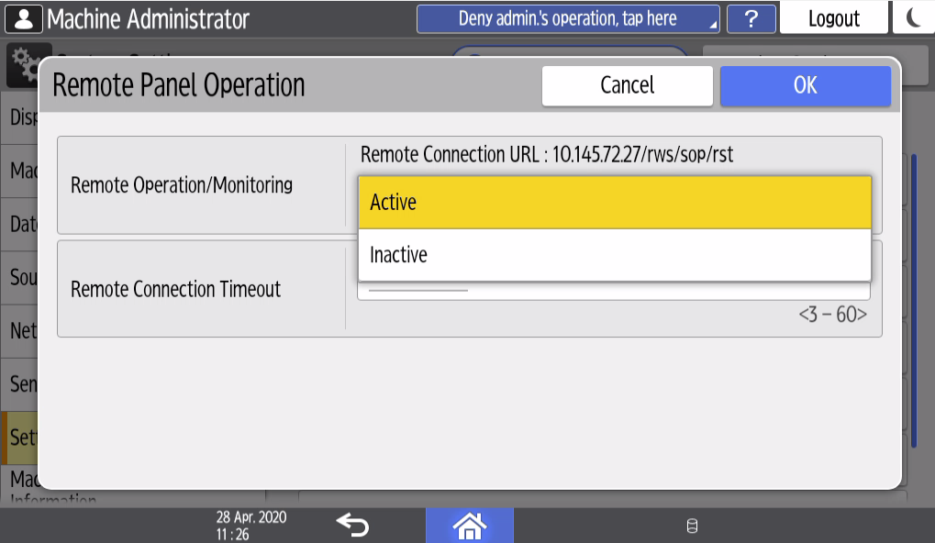

# Setup of Home Key Application Setting (SOP Devices / SOP Devices IMC Series)

To setup the Genius Bytes application as Home key priority on SOP devices you must change the settings on the device. On small locations with a small amount of devices to rollout you can setup the device priority function over the display of the device as follow.

*For larger rollouts / mass settings, ask your local Infineon contact to assist with automated device settings over the Service Provider SanData in Germany / Austria.*

**Manual setup of Home key priority to Genius Bytes MFP Client**

1. Starting the Special SP Mode. (Reset\_806182\_##\_C(hold 5 seconds))  
     
   Copier 
   a O Ready 
   eee 
   <BLack & White> 
   Store File 
   Bypass 
   Auto Color Select 
   Full Color 
   Black & White 
   Text 
   Photo 
   Text / Photo 
   Others 
   Auto Density 
   Original 
   Auto Paper 
   Select» 
   Check Modes 
   Orig. Orientation 
   4 
   7 
   Reset 
   5 
   8 
   Full Size 
   Auto Reduce / Enlarge 
   I sided* 2 sided: TtoT 2 sided* 2 sided 
   I sided*Comb 2 orig I 
   sided*Comb 4 orig 
   na 
   6 
   9 
   Enter 
   Create Margin 
   Plinth 
   Stack 
   Finishing 
   Staple 
   Cover/Slip Sheet 
   Clear 
   Edit / Color 
   Dup./Combine/Series Reduce / Enlarge 
   Simplfied Scrn. 
   Recall/Program/Change Program D Interrupt mode 
   Check Status 
   _l_uu_ 
   Sample Copy 
   0 
   Start 
   Stop 
2. after Special SP , select „User Tools“.  
   

1. select „Screen Device Setting“  
     
   Screen Features Settings 
   Device 
   Storage & USB 
   Apps 
   Personal 
   n Language & input 
   System 
   Screen Device Settings Information 
   Screen Device Settings 
2. select „Home Key Settings“.  
   9System Home SLNX Scan 
   e Screen Device Settings 
   Use of External Interface 
   Server Settings 
   Home Key Settings 
   SLNX Secure Print 
   Admin. is operating remotely 
   Logout 
3. select „Home Key Application“.

e Home Key Settings 
Home Key Settings 
Home Key Assignment Mode 
Home Key Application 
Show default Home for unauthenticated user 
System Home Key Icon Settings 

1. choose „GeniusMFP“ as Home Key  
   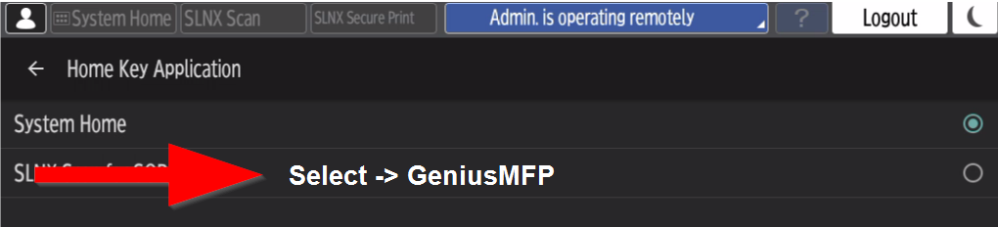
2. go back and logout.

# Setup of Back Key Setting (SOP Devices)

WIM -> Device Management -> Configuration -> Screen -> Screen Device Settings





# Setup of Back Key Setting (SOP Devices IMC Series)

WIM -> Device Management -> Configuration -> Screen -> Screen Features Settings Display/Input ->Display

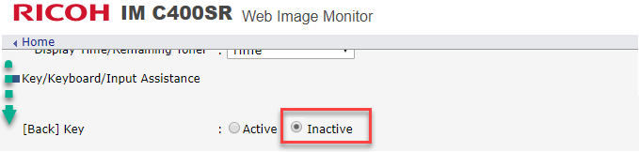

# Setup of Screen Startup Mode (SOP Devices IMC Series)

SOP PANEL: Settings -> Screen Features Settings -> Screen Device Settings -> Screen Startup Mode -> NORMAL  
(Devices with the new ACT Menue: System Settings -> Machine -> Power/Energy Saving-> Control Panel Startup Mode -> NORMAL)

# Setup of Card Reader (SOP Devices IMC Series)

SOP PANEL:

Settings -> Screen Features Settings -> Screen Device Settings -> External Interface Software Settings -> Proximity Card Reader  
  
Settings -> Screen Features Settings -> Screen Device Settings -> External Interface Software Settings -> Proximity Card Reader Software Settings: VID1DA6 / PID 0110

(Devices with the new ACT Menue: System Settings -> Network/Interface -> External Interface Software Settings)

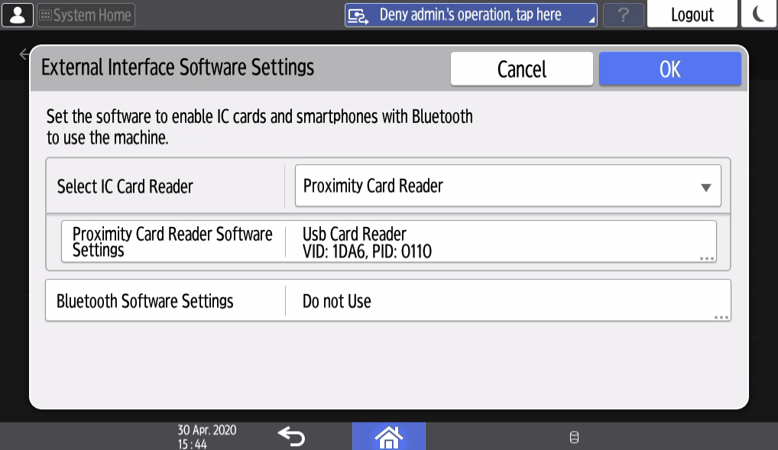

# Screen Device Always-Connection Setting (SOP Devices IMC Series)

SOP PANEL (Login as Service (Special Service Program – SSP)):

Settings -> Screen Features Settings -> Screen Device Settings -> Screen Device Always-Connection Setting -> ACTIVE

# Enhanced External Charge Unit Management

SP 5 113 02 (External Optional Counter Type) = 1 (with Java) / 0 (without Java)

# DOSS and HD Encryption

DOSS and Encryption should be enabled as the final setup steps as these may take while to complete!

|  |
| --- |
| * User Tools >> System Settings >> Administrator Tools 3/4 >> Auto Erase Memory Setting >> ON: DoD   (For SOP Devices: User Tools >> Machine Features >> System Settings >> …) |
| * Ensure Data Encryption is installed and/or enabled >> (SP-5-878-002) EXECUTE |
| * User Tools >> System Settings >> Administrator Tools 4/4 >> Machine Data Encryption Settings >> Encrypt >> Format All Data   (For SOP Devices: User Tools >> Machine Features >> System Settings >> …) |
| * Press Start key to print encryption key after encryption is completed |
| * Tape encryption key to the glass (if done offsite) or give to your Infineon contact * Exit and Reboot the Device |
| DOSS and HD Encryption (IMC Series) DOSS and Encryption should be enabled as the final setup steps as these may take while to complete!   |  | | --- | |  | | * Ensure Data Encryption is installed and/or enabled >> (SP-5-878-002) EXECUTE | |  | | * Press Start key to print encryption key after encryption is completed | | * Tape encryption key to the glass (if done offsite) or give to your Infineon contact | | * Exit and Reboot the Device | |

# Complete Device Configuration

To complete device configuration please follow steps of **“Infineon\_MFP-Device Configuration”-file**. Please note the needed settings for SNMP (TRAP) for the remote configuration / monitoring over Device Manager NX.

# Appendix

## SDK-J & Firmware requirement

Ricoh ETC and Genius Bytes approve the named SDK-J and Firmware.

The FW and SDK-J Version guarantee us to service and update the devices remote over DMNX-Enterprise from IFX Germany / Austria.

### Minimum Version of SDK-J

MP C3003 equal or newer as 11.37

MP C3004 equal or newer as 12.39.02

MP C3004ex equal or newer as 12.39.02

MP C306Z equal or newer as 12.39.02

MP C3503 equal or newer as 11.37

MP C3504 equal or newer as 12.39.02

MP C3504ex equal or newer as 12.39.02

MP C401 equal or newer as 12.39.02

IM C20/25/30/35/40/45/55/6000 equal or newer as 12.63.00

IM C300/400/400F equal or newer as 12.66.02

### Minimum Version of Firmware

MP C3003 - System/Copy equal or newer as 1.32

MP C3004 - System/Copy equal or newer as 1.26

MP C3004ex - System/Copy equal or newer as 1.13

MP C306Z - System/ Copy equal or newer as 1.11

MP C3503 - System/Copy equal or newer as 1.32

MP C3504 - System/Copy equal or newer as 1.26

MP C3504ex - System/Copy equal or newer as 1.13

MP C401 - System/Copy equal or newer as 1.12

IM C20/25/30/35/40/45/55/6000 - System/Copy equal or newer as 1.06

IM C300/400/400F - System/Copy equal or newer as 1.03