Relocating Badge Reader

Separate the Finisher from the Ricoh Printer.

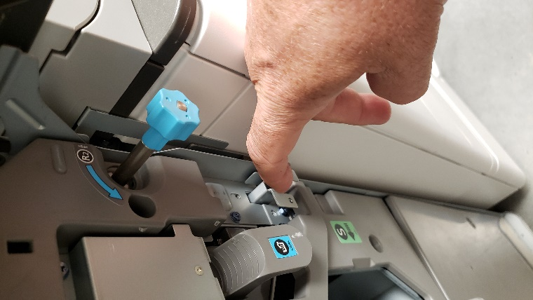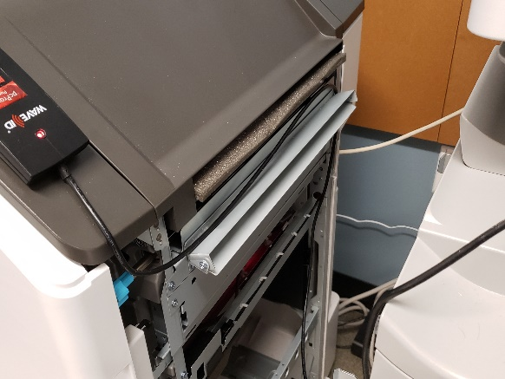

Unplug the USB cable from the badge reader in the back USB port.

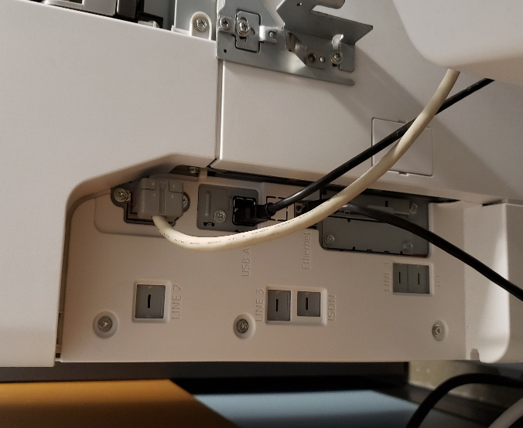

Run the USB cable under from the reader to the Smart Operation Panel, and plug in USB. Please hide excess cabling, tuck away as much as possible.

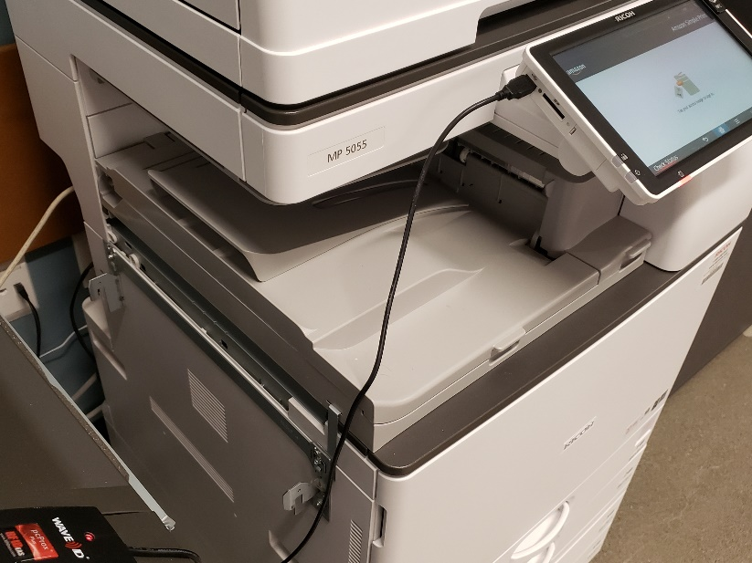

Verify connection light is lit on reader.

Reattach Finisher.

Please work with the local contact to send a document to Simple Print to test. Please note that the end user will need to have updated their drivers, found at *It.Amazon.com/simpleprint,* to the new platform. Then have the Amazonian scan their badge to retrieve their print job and select

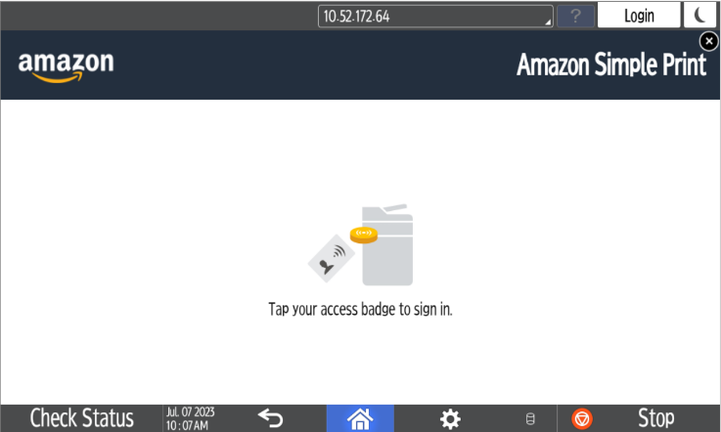‘Print All’ to print the document. Touch the ‘Sign Out’ button when finished.

