Relocating Badge Reader

Separate the Finisher from the Ricoh Printer.

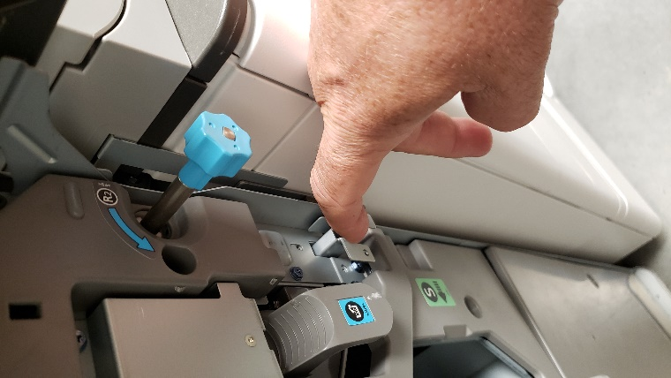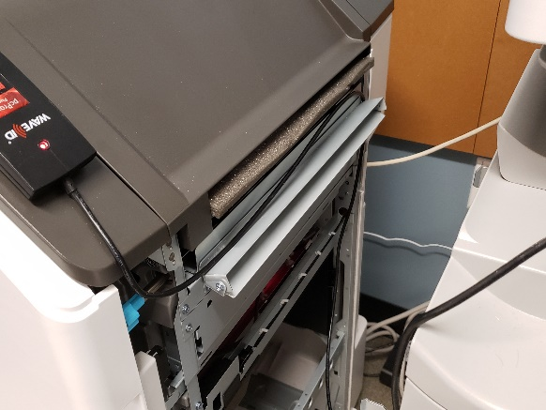

Unplug the USB cable from the badge reader in the back USB port.

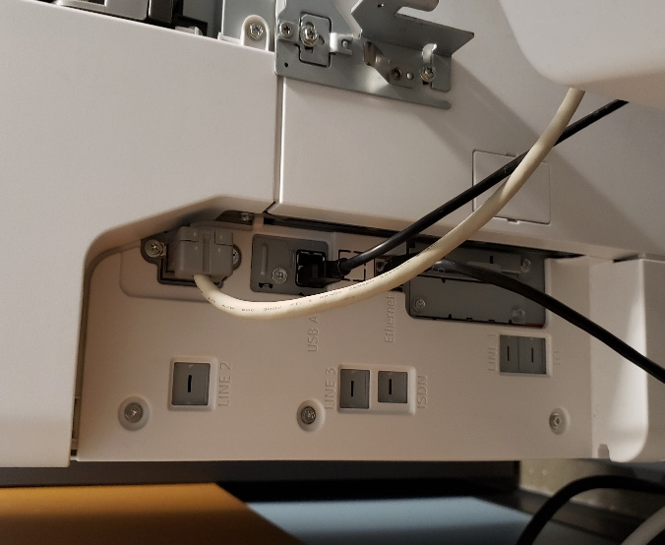

Run the USB cable under from the reader to the Smart Operation Panel, and plug in USB. Please hide excess cabling, tuck away as much as possible.

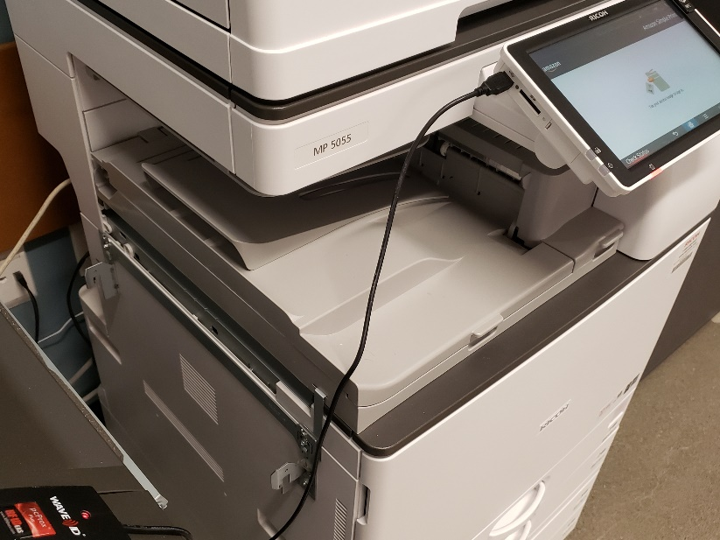

Verify connection light is lit on reader.

Reattach Finisher.

Please work with the local contact to test by printing a test document.

Note: The user will need to update their print software. They can install the new software from *It.Amazon.com/simpleprint*

Have the user scan their badge to retrieve test print and select ‘Print All’ to print the document. Touch the ‘Sign Out’ button when finished

