**RFIDEAS pcProx Configuration Utility**

Step 1. Connect the card reader to a laptop

Step 2. Download the RFIDEAS pcProx Configuration Utility from: <https://www.rfideas.com/support/tools/downloads>

Step 3. Start the utility and click the **Connect** button to connect the utility to the card reader

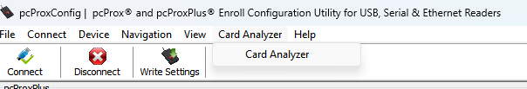

Step 4. Select **Card Analyser** from the menu



Step 5. At this point you will need to place a card onto the reader then select **Learn Card**

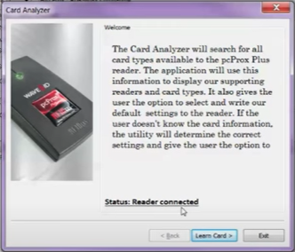

Step 6. After some minutes the reader will have analysed the card. Click **Write** to write the configuration to the card. Click **Exit.**

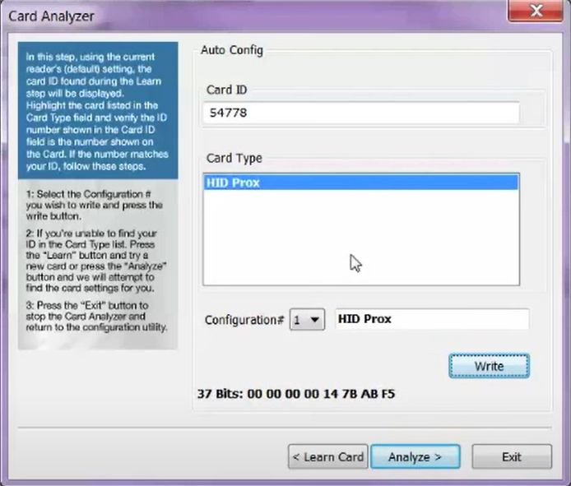

Step 7. The Configuration Utility will then return to the configuration screen. Click the **Format** tab.Ensure that **Send ID as hexadecimal number** is selected.

Please do not replicate the other settings shown within the other fields shown in the image below as these settings may differ depending on the card type that may not match the location’s card configuration.

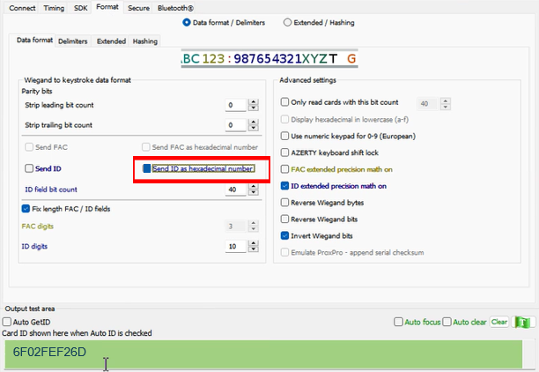

Step 8. Swipe a number of cards (3 minimum) from the location and ensure that the values are unique for each card. In addition, the quantity of digits should now read:

1. In hexadecimal format
2. The quantity of digits should be a minimum of 10 digits
3. Remove leading 0’s

To test, either use notepad or the following area in the Configuration Utility by selecting **Auto GetID**. If the settings are not matching the requirements listed above, then reconfigure the card reader configuration until the expected configuration is reached.

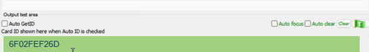

Step 9. Once the settings are configured, click **Write Settings** and exit the Configuration Utility.

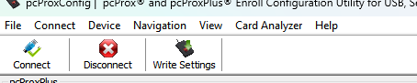

Note. If there are multiple card readers at the location, it is possible to export the saved configuration and import to other card readers. To do so, select **Save device data to hwg+file**. This configuration can then be uploaded to other unconfigured card readers using the **Open hwg/hwg file…** setting to write the completed configuration information to other readers.

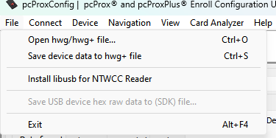

**Troubleshooting:**

**CARD Reader standardization (this standard is to be set on all readers)**:

1. All card reader should read only 10 digit.
2. Card reader should reader Hexadecimal numbers.
3. Leading ZEROs should be removed.