# 28 Security – Device Certificate

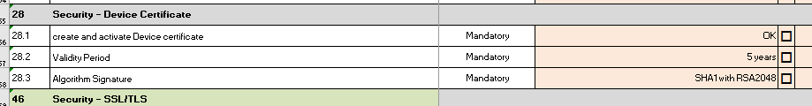

## 28.1 create and activate Device certificate steps:

**login administrator account in WIM**

**click “device management'- configuration**

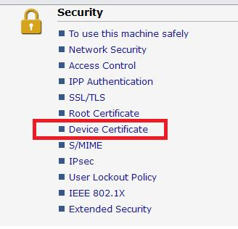

**Select Certificate1 and Click ‘Create’ button**

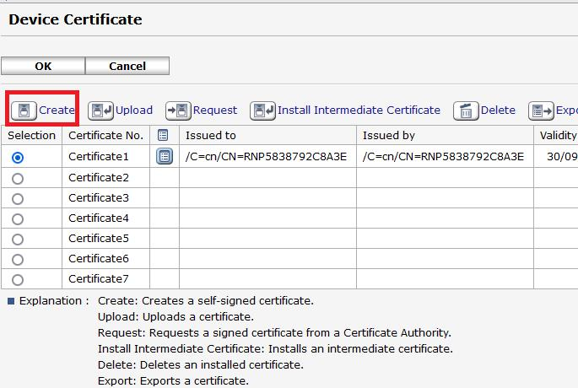

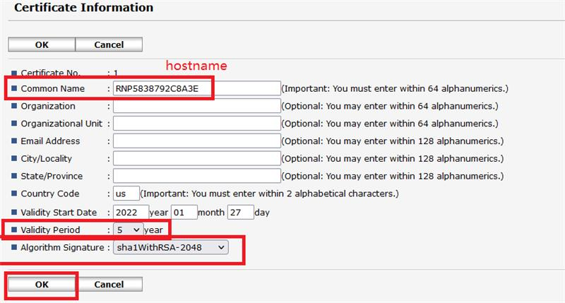

**Fill up (mandatory):**

Common Name: <hostname>

Country Code: ID

Validity Start Date: <today’s date>

Validity Period: 5

Algorithm Signature: SHA1 with RSA-2048

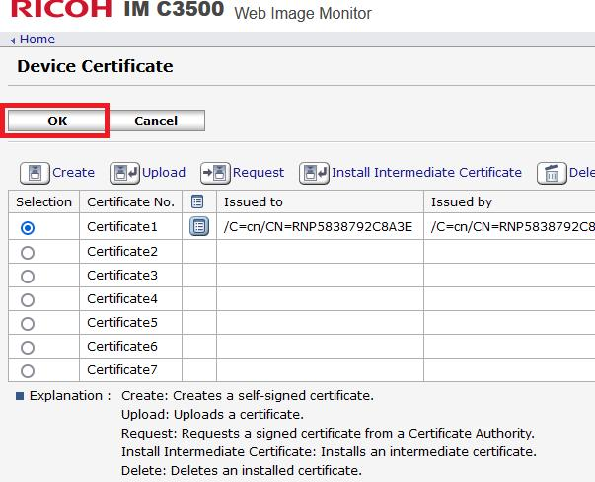

**end**