**Set up Proximity Card Reader on IM Devices with G2 Panel**

*\*Note: Troubleshooting Steps at the bottom of the page*

Log into the SOP Screen User tools – Screen Device Settings

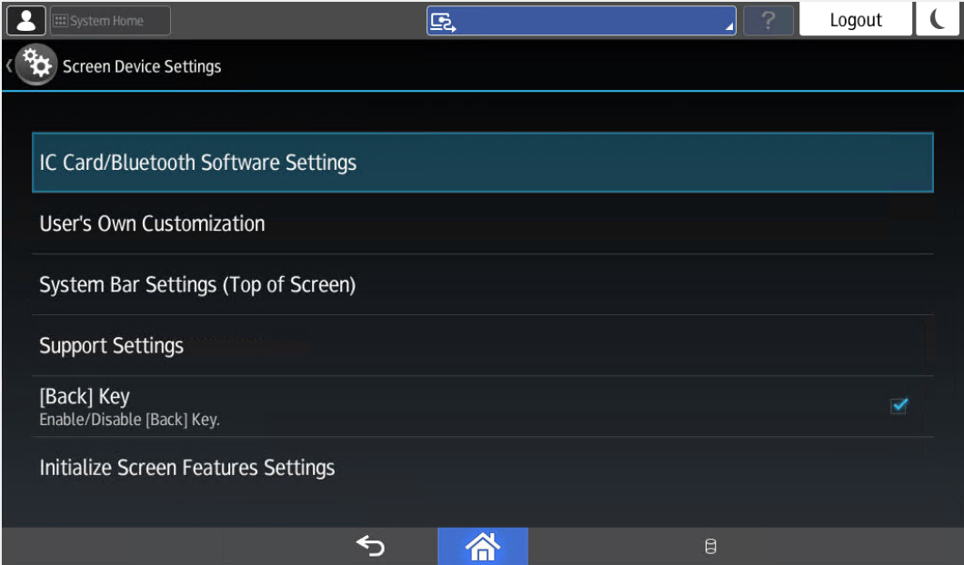

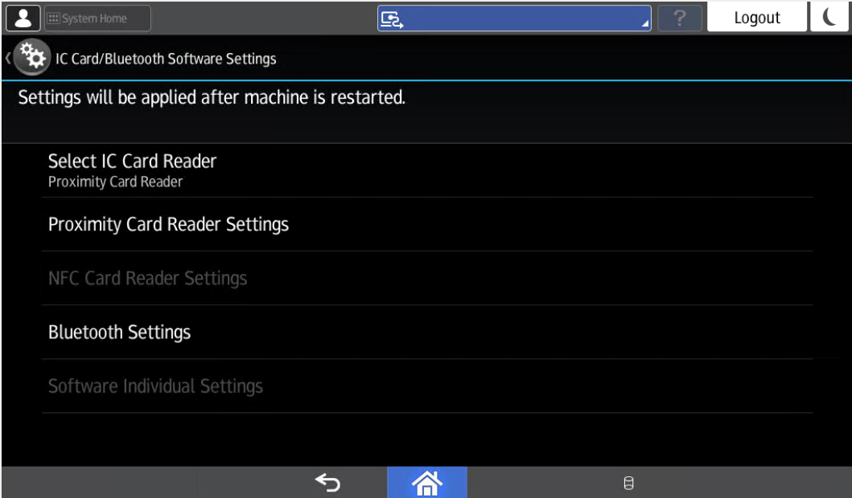

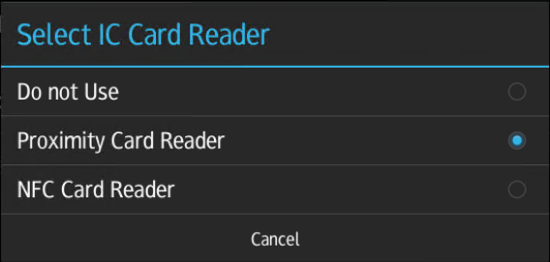

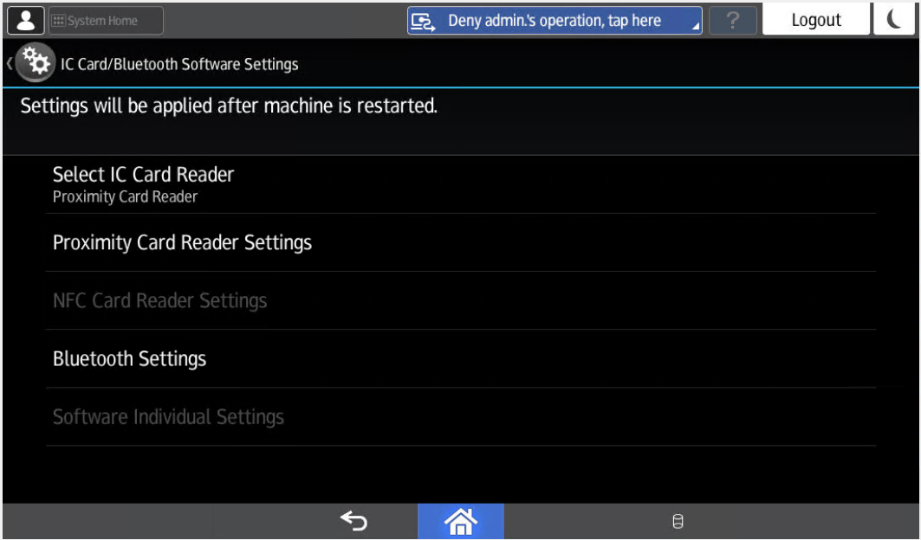

Plug in card reader to populate next screen. **Select** the Proximity Card Reader Support Plugin

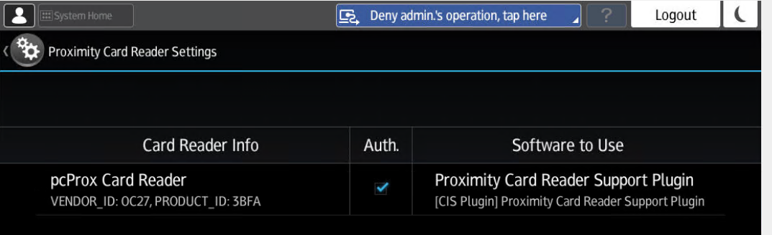

**Select** *“Do Not Use”*

**Set up Proximity Card Reader on IM Devices with G2.5 Panel**

**Log in to the machine as the machine administrator on the control panel.**

[Logging in to the Machine as the Administrator](http://support-download.com/services/device/webhlp/p_manual/europe/IMC8000/en/security/int/administrator.htm#0006)

**2On the Home screen, press [Settings].**

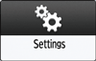

**3On the Settings screen, press [System Settings].**

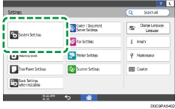

**4Press [Network/Interface][External Interface Software Settings].**

**5From the list next to Select IC Card Reader, select the type of the IC card reader to use.**

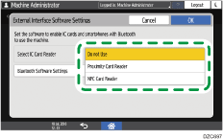

To use FeliCa, select [Proximity Card Reader]. To use NFC, select [NFC Card Reader].

**6To use a smart device to authenticate, press [Bluetooth Software Settings] and select [Bluetooth Authentication Plugin] from the list next to Bluetooth.**

Check that the [Active] check box under Authentication is selected, and then press [OK].

**7Press [OK].**

Troubleshooting SOP

If there is no response from the card reader when trying to Authenticate.

1. Unplug the card reader
2. Reboot the device
3. Wait for the application to fully load
4. Plug the card reader back in
5. Wait 5 seconds (yes, 5 full seconds)
6. Badge in to test authentication

Troubleshooting ESA

These are the steps I took to resolve the issue with that badge reader:

1. I disabled the card reader in the screen settings (the opposite of the original installation instructions), unplugged the card reader, and then reset the device.
2. I then set:
3. SP 5-919-001 to 0
4. SP 5-305-101 to 0
5. SP 5-113-001 to 0 (which it is by default)
6. SP 5-305-101 to 1
7. Then I enabled the card reader through screen settings (card reader then the proximity option), plugged in the card reader, and rebooted the device.
8. And last, in Administrator Tools, I selected Enhanced external charge unit management and highlighted the Document Server.
9. Reboot once more.