1. Prox card reader is handled by LRS. If the following is set and you are having a card issue the MFPs prox card settings are taking priority over the LRS on reboot or coming out of sleep, please remove the following in this order.
2. Login to machine.
3. Goto Screen Features and then Screen Device settings. 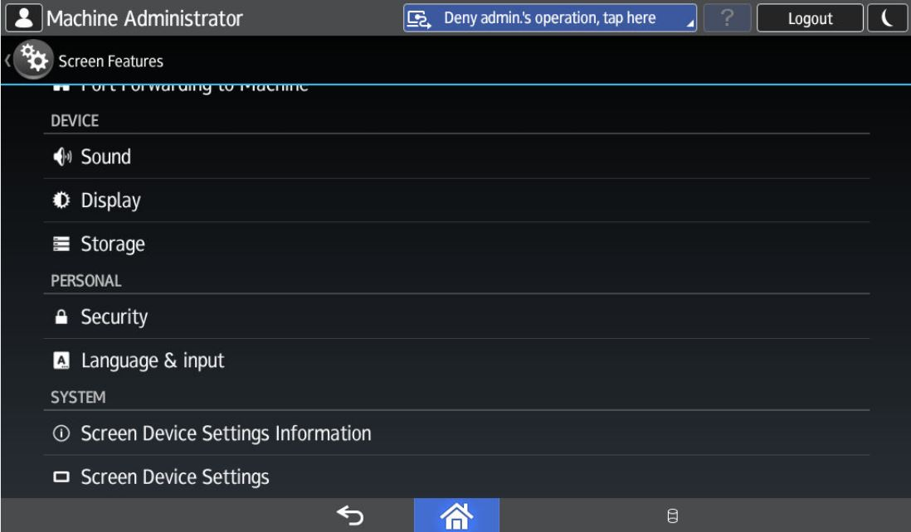
4. Choose IC Card/Bluetooth Software Settings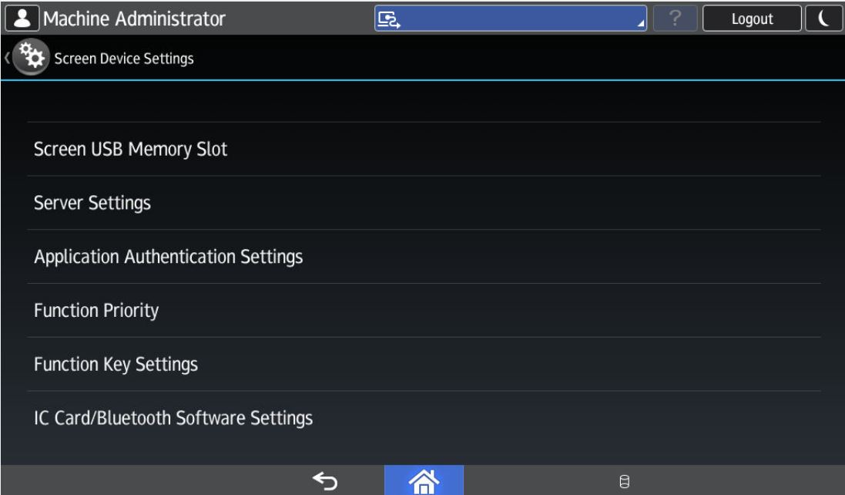
5. Card reader settings. Choose Do not Use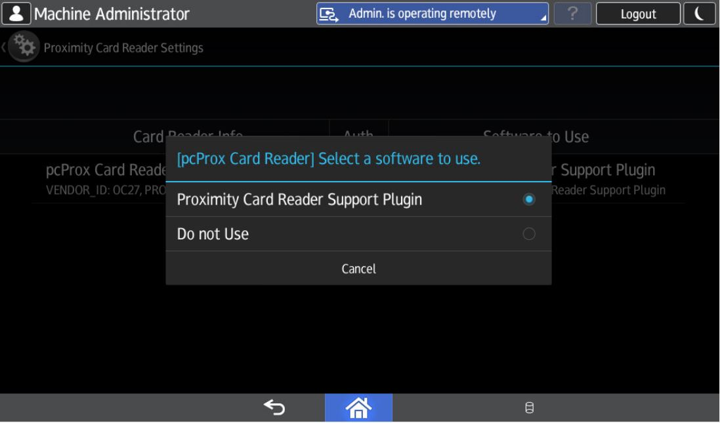
6. Select IC Card Reader. Choose Do not Use.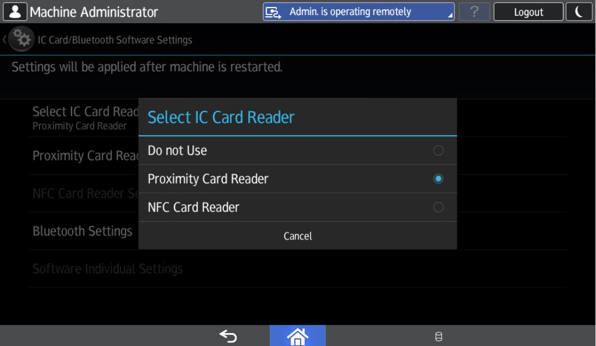
7. This is what it should look like in the end.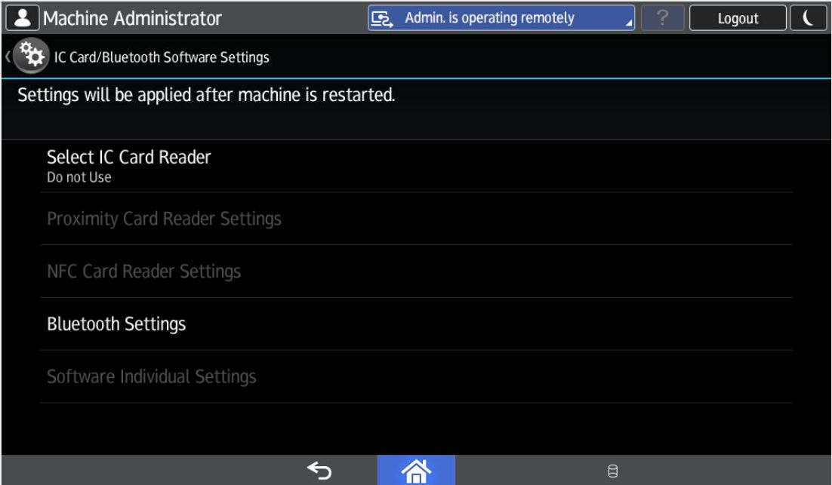
8. Deep sleep mode should be disabled. Instructions are following.
9. Card reader always on should be enable. Instructions are following.

Disable Deep sleep mode

1. Remove cover from left side of Smart Operation Panel revealing 3 buttons. 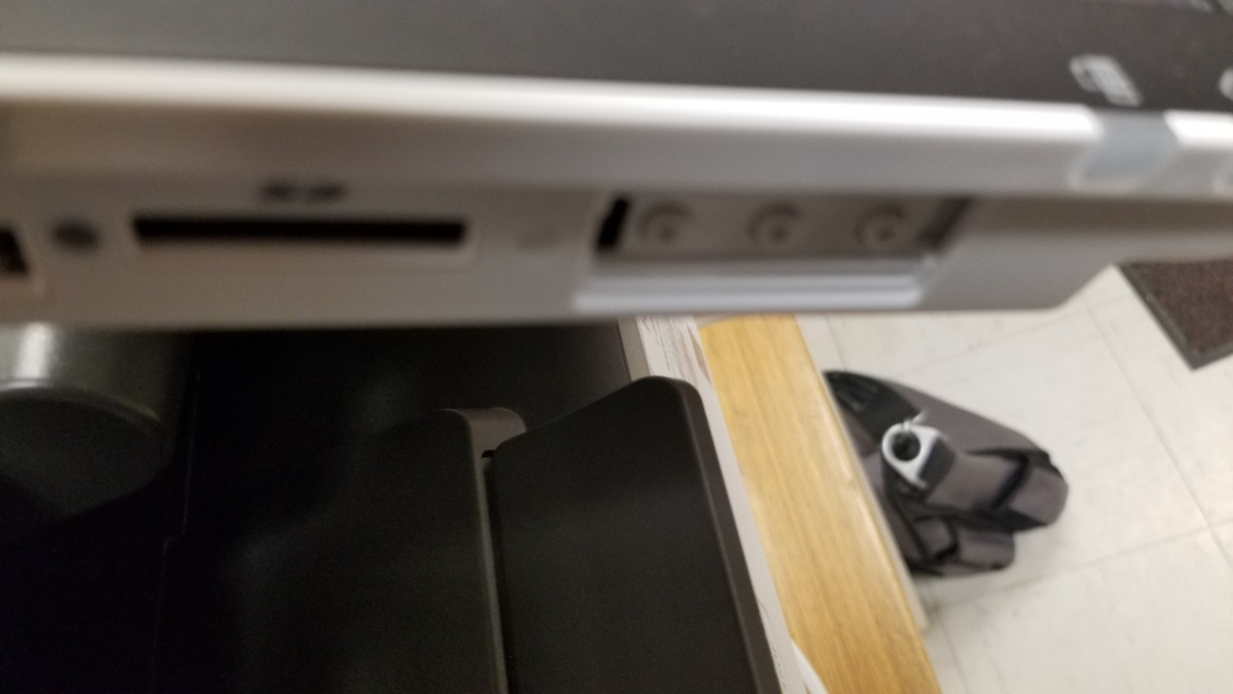
2. Press and hold the lower most button and the check status area on the panel until panel changes to number pad. 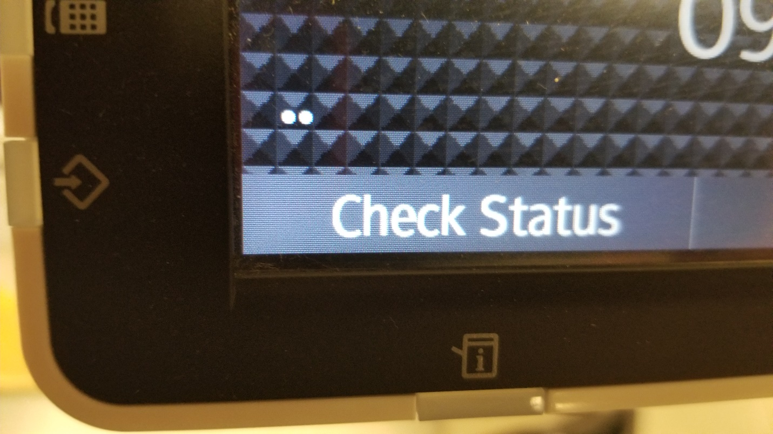
3. Hit RESET 806182 and then hold the clear button until service mode appears. 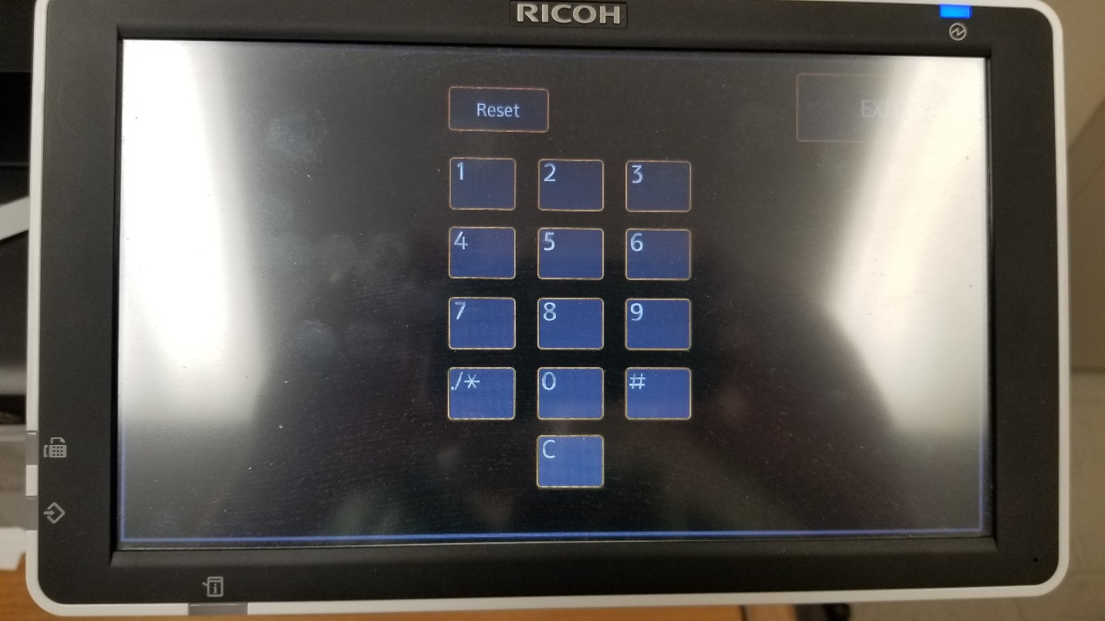
4. Click the System SP button. 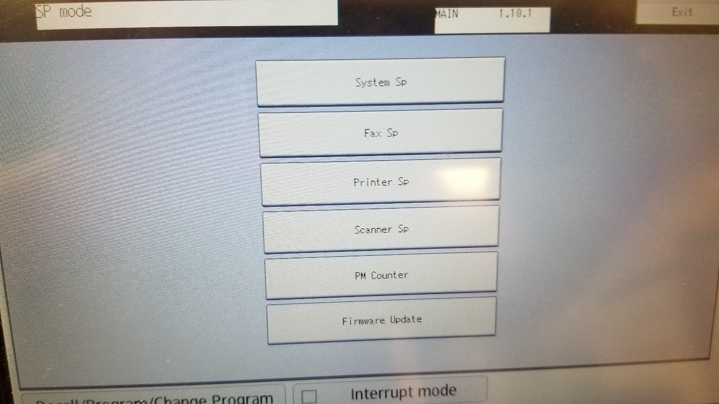
5. Type 5305 # in the SP direct mode. SP Direct should be highlighted. If not, click SP Direct.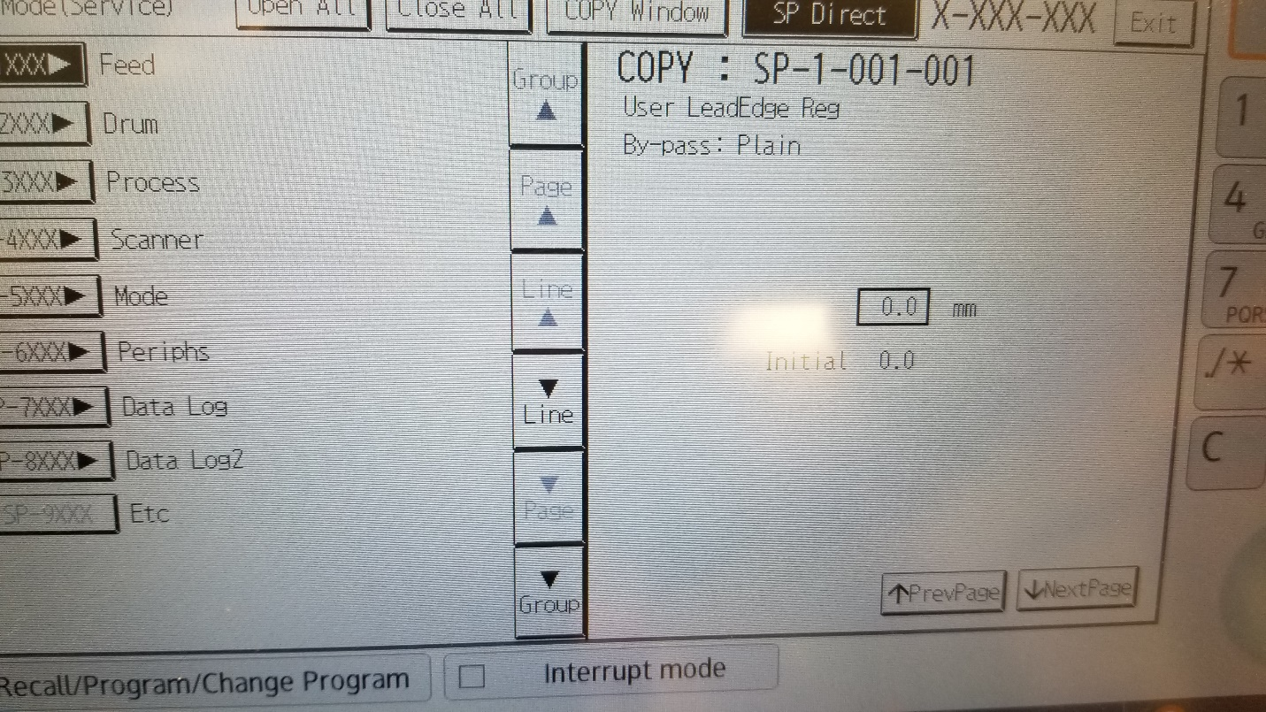
6. In SP5-305-101, change 1 to 0 and then #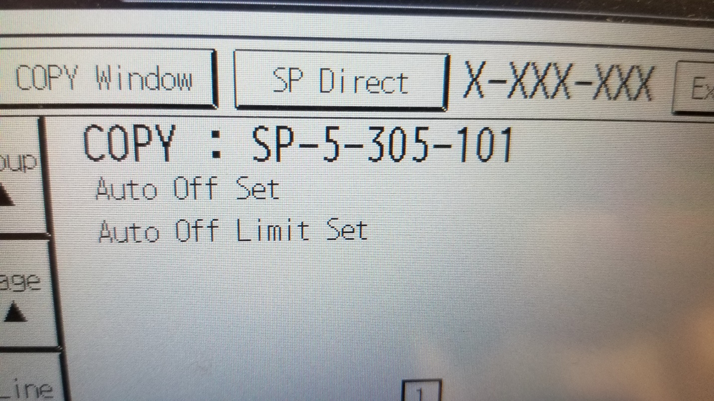
7. Hit the exit button multiple times until the logout button appears, then logout.
8. Restart machine.
9. Goto to user tools, machine features, and login as administrator
10. Click the Administrator Tools tab.
11. On the 2nd or 3rd page depending on model, you will find Sleep Mode Entry by Sleep Mode Time. Click button and choose to disable. Hit the exit button until you get to a point you can logout.

Disable Card Reader Power-off

1. Remove cover from left side of Smart Operation Panel revealing 3 buttons. 
2. Press and hold the lower most button and the check status area on the panel until panel changes to number pad. 
3. Hit RESET 806182## and then hold the clear button for approximately 5 seconds and then release. 
4. Choose Screen Device Settings. Click on Screen Device always-connection Setting. It should be set to active.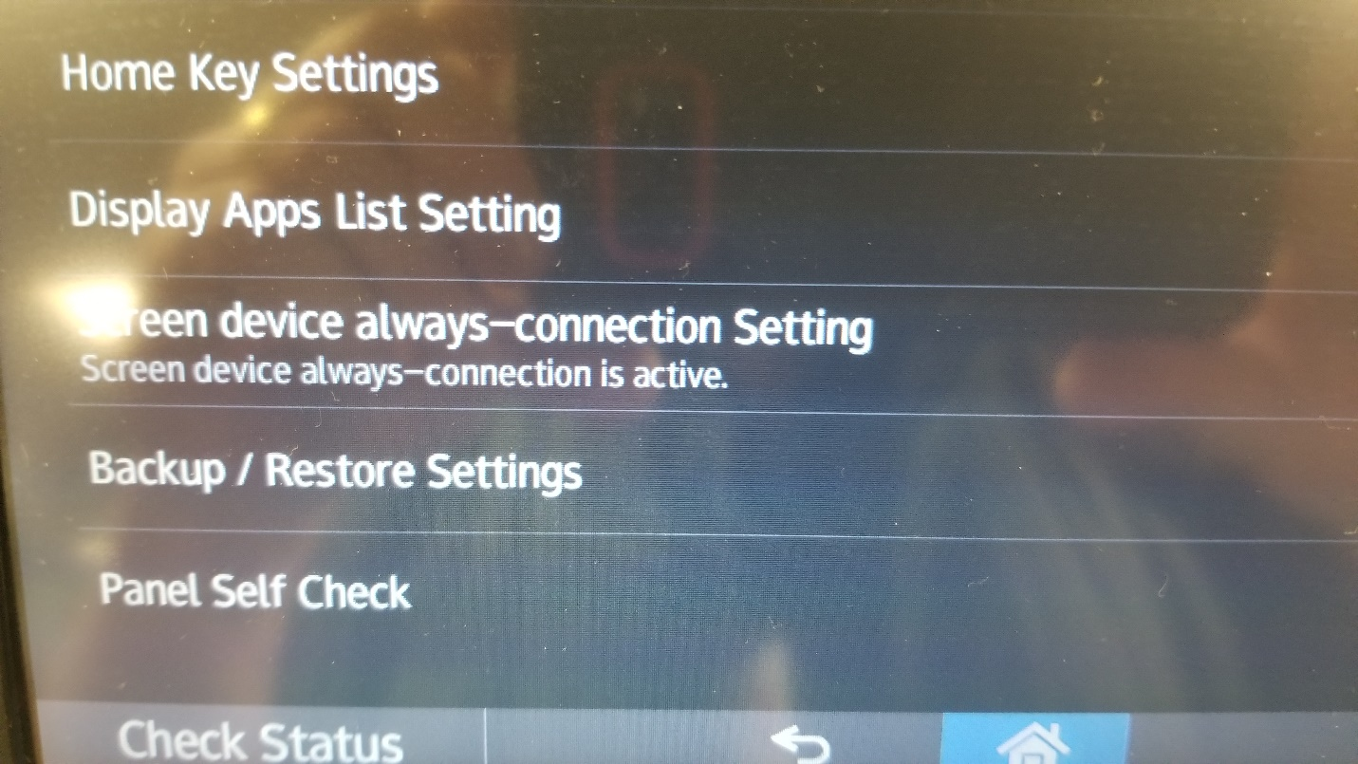
5. Logout and restart machine.