Disable Card Reader Power-off

1. Remove cover from left side of Smart Operation Panel revealing 3 buttons. 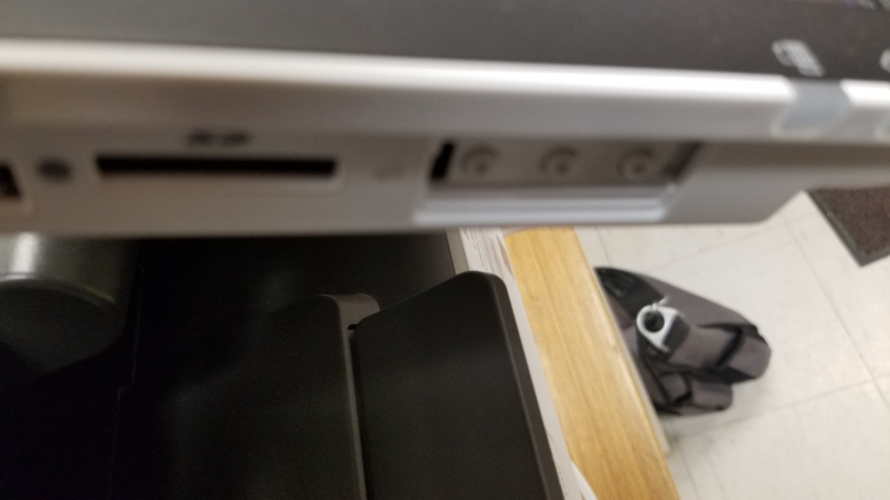
2. Press and hold the lower most button and the check status area on the panel until panel changes to number pad. 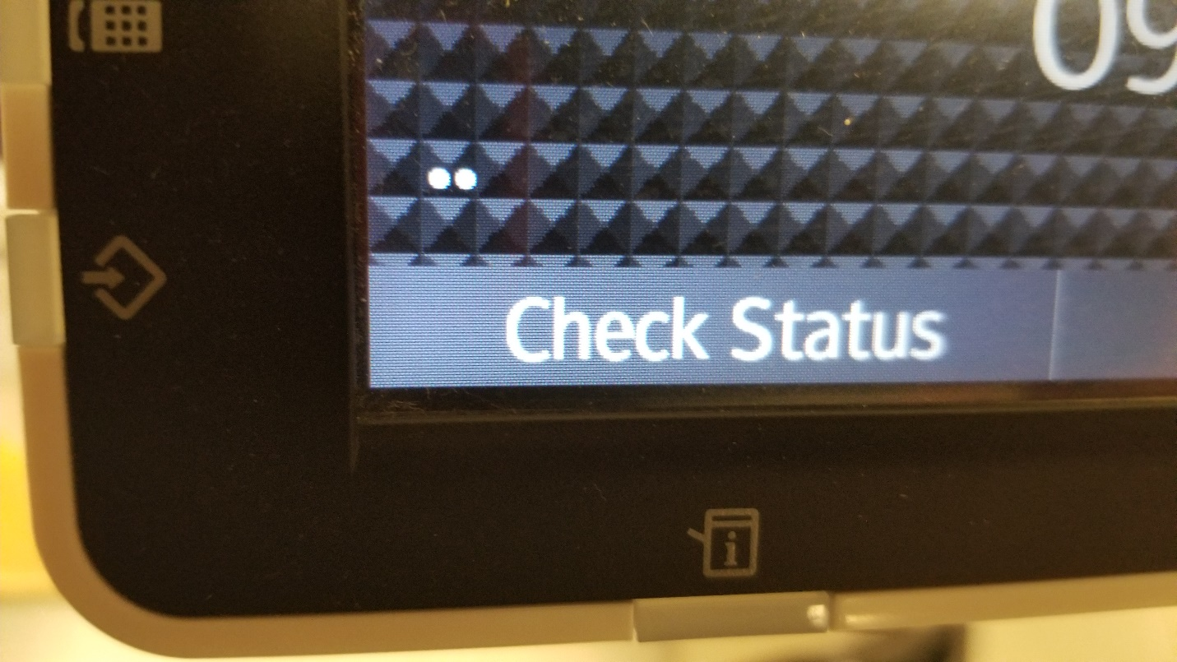
3. Hit RESET 806182## and then hold the clear button for approximately 5 seconds and then release. 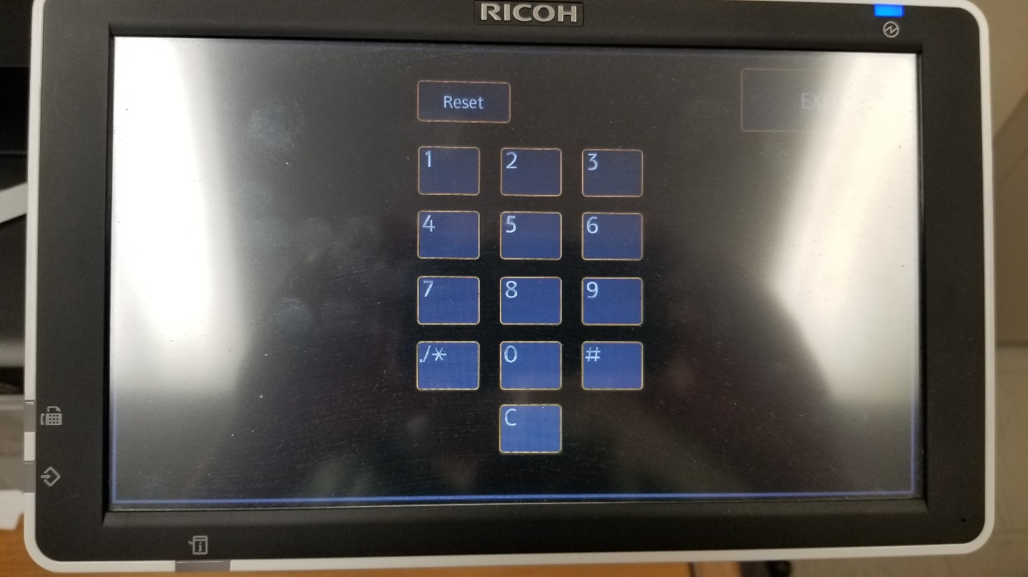
4. Choose Screen Device Settings. Click on Screen Device always-connection Setting. It should be set to active.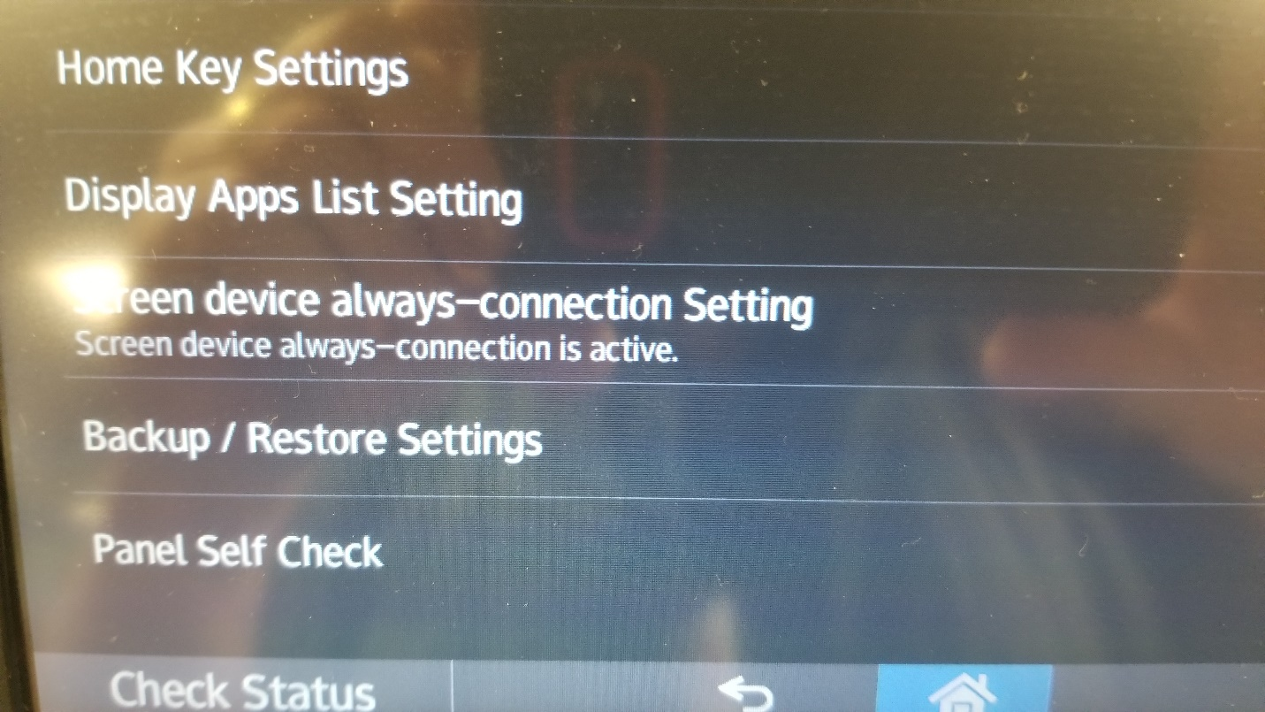
5. Logout and restart machine.