Disable Deep sleep mode

1. Remove cover from left side of Smart Operation Panel revealing 3 buttons. 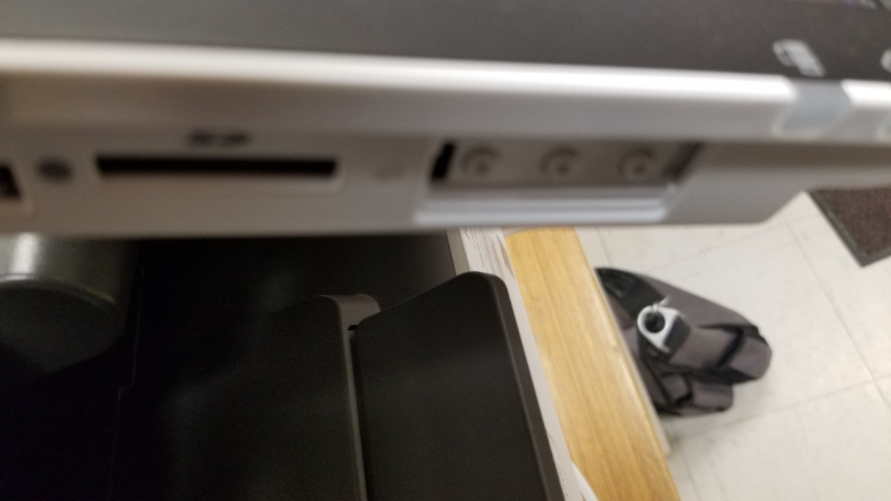
2. Press and hold the lower most button and the check status area on the panel until panel changes to number pad. 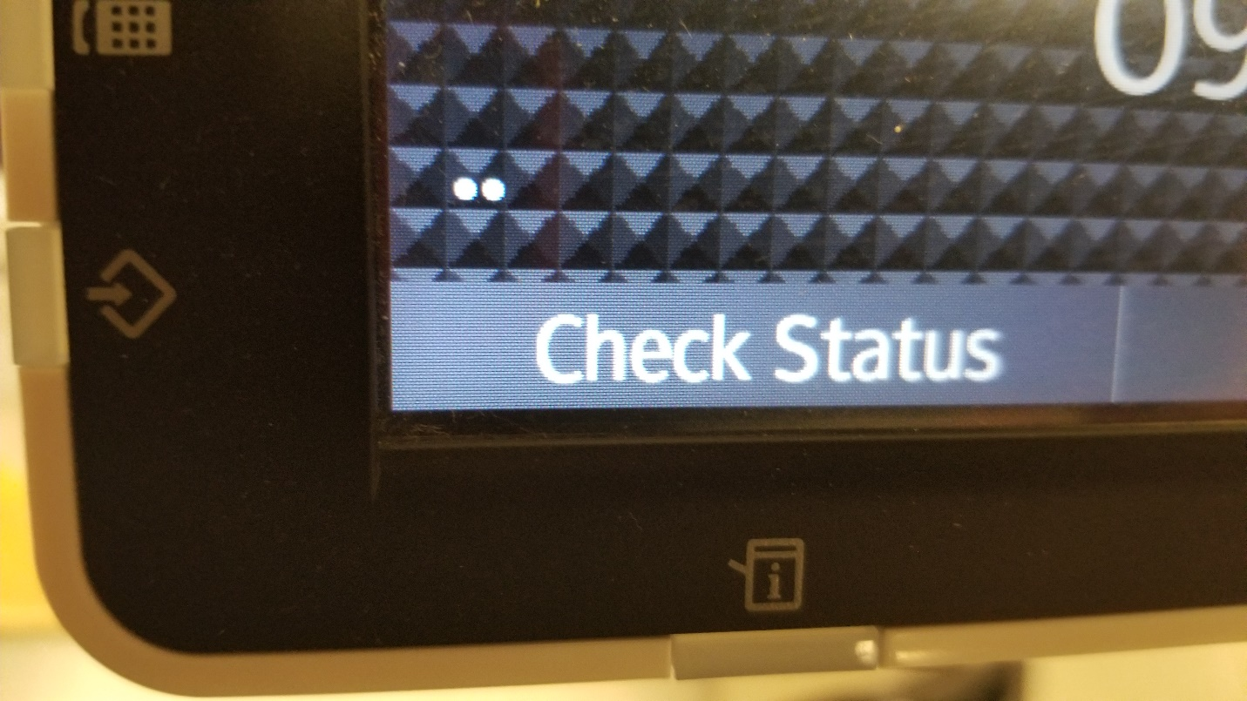
3. Hit RESET 806182 and then hold the clear button until service mode appears. 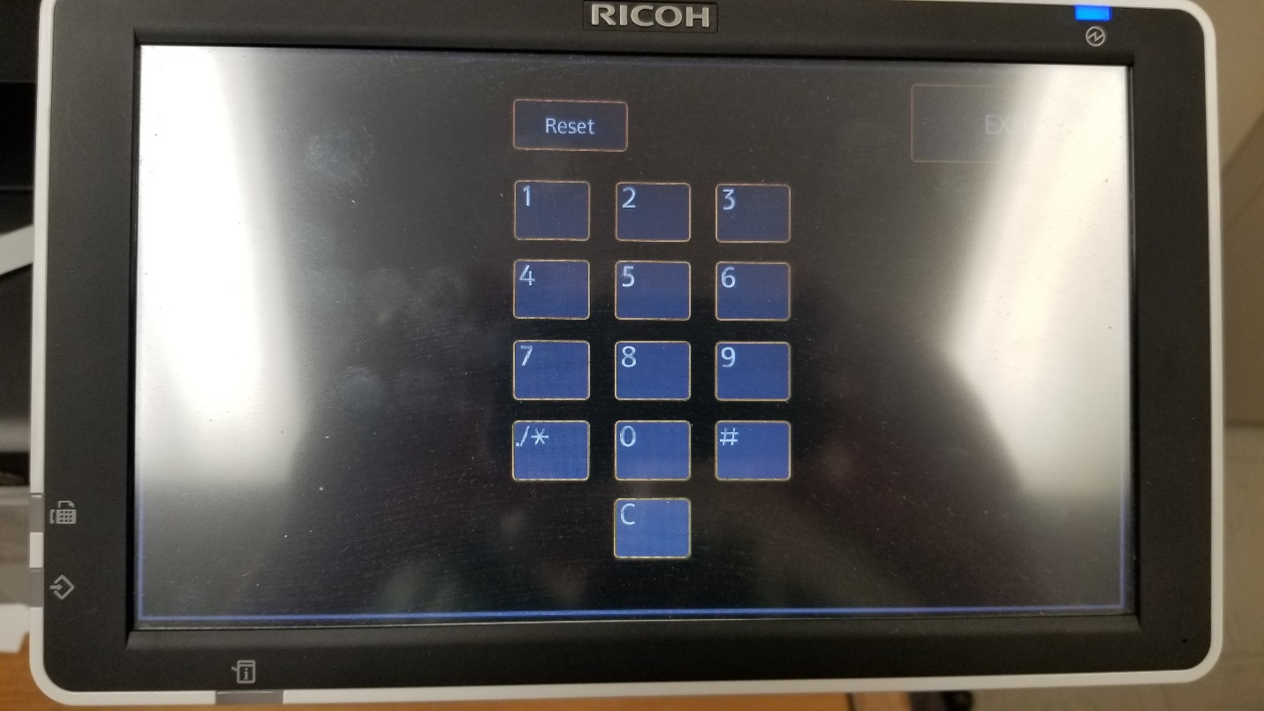
4. Click the System SP button. 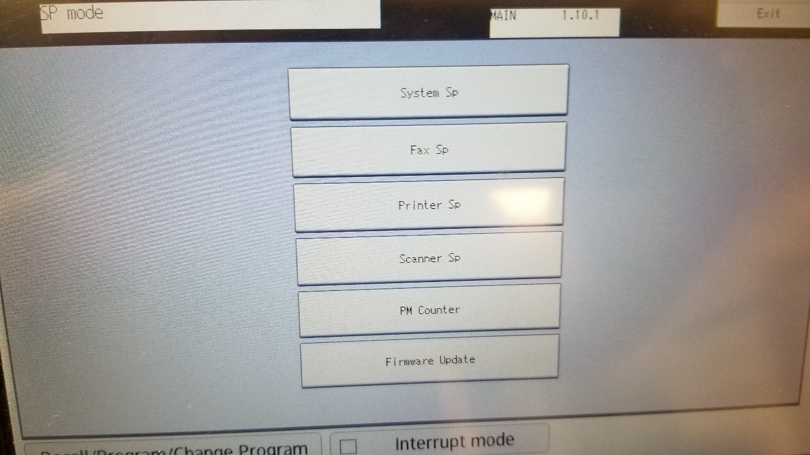
5. Type 5305 # in the SP direct mode. SP Direct should be highlighted. If not, click SP Direct.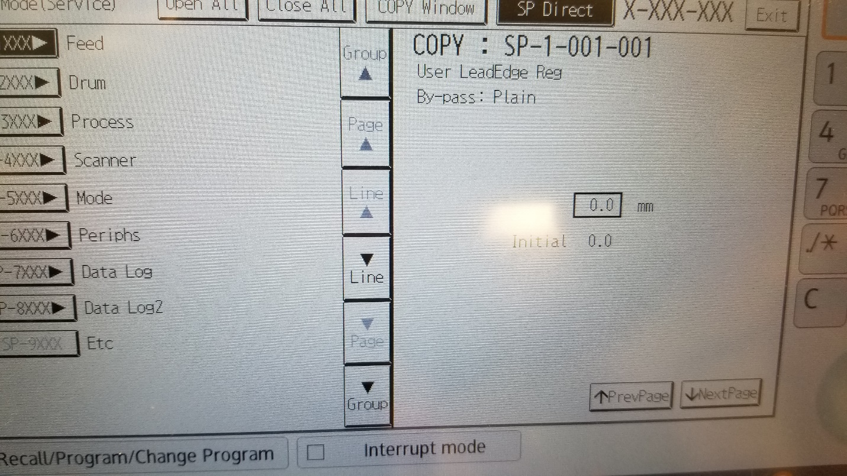
6. In SP5-305-101, change 1 to 0 and then #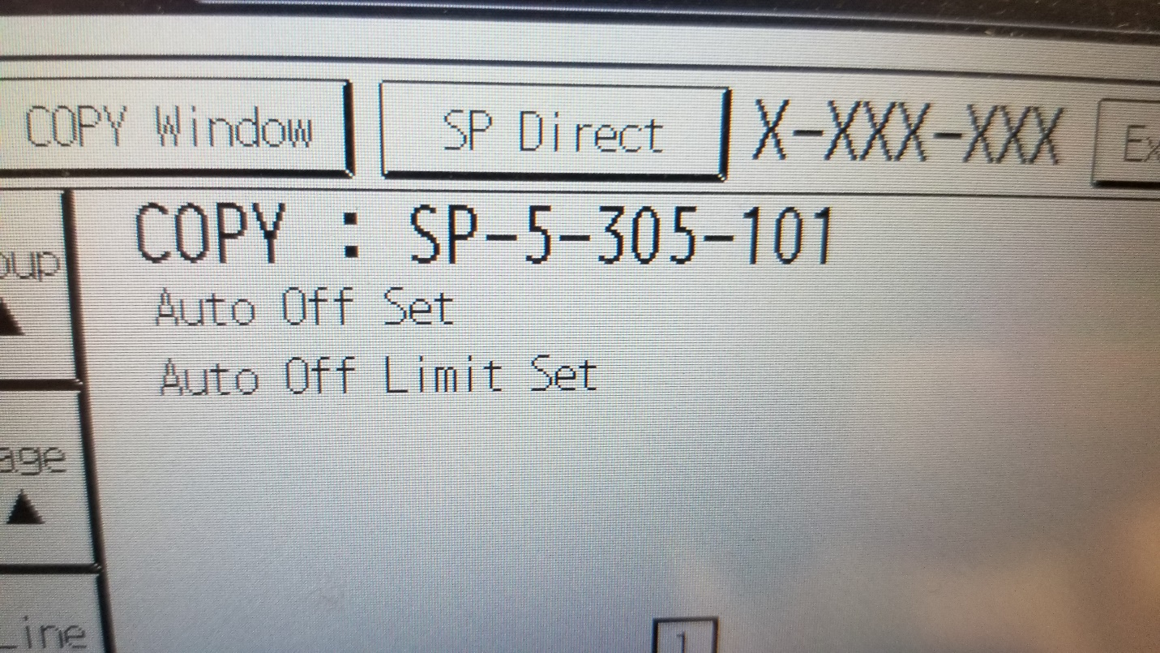
7. Hit the exit button multiple times until the logout button appears, then logout.
8. Restart machine.
9. Goto to user tools, machine features, and login as administrator
10. Click the Administrator Tools tab.
11. On the 2nd or 3rd page depending on model, you will find Sleep Mode Entry by Sleep Mode Time. Click button and choose to disable. Hit the exit button until you get to a point you can logout.