Henkle - Build Book for MFP Secure Deployment

# Device preparation for Smart Op Panel Devices

#### This section applies to IM 430, IM C4500, MP 501, MP 4055, MP 5055, MP C406, MP C407, MP C4504 and MP C4504EX

Compatible with MFPSecure ​**RFIDeas RDR-80581AKU (product number 934189)** – base for this document

1. Program and install badge reader
   1. Ricoh RFIDeas RDR-80581AKU is configurable and needs to be adjusted for your badge card
      1. Config tool pcProxConfig-5.3.3. from https://www.rfideas.com/support/tools/downloads
   2. Configuration Steps
   3. Start pcProxConfig​
   4. Connect Card reader to the PC (USB)​
   5. 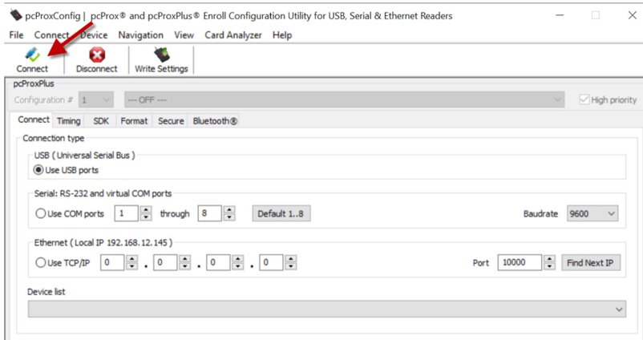Click on “Connect”
   6. The reader should be recognized after a while​

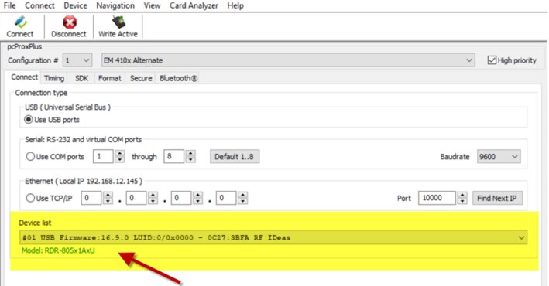

* 1. Go to Card Analyzer

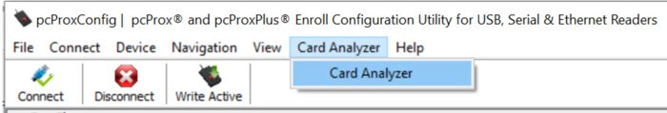

* 1. Go to Learn Card, press Start Scan to learn your card and put badge card on the reader and leave it there

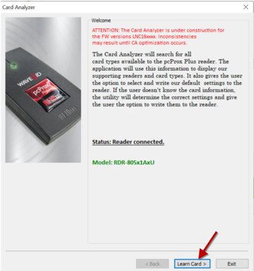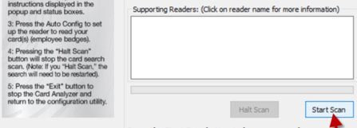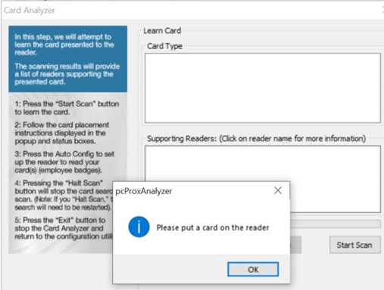

* 1. Let the scan process run, go to Auto Config and remove the card from the reader

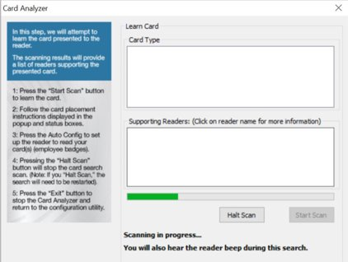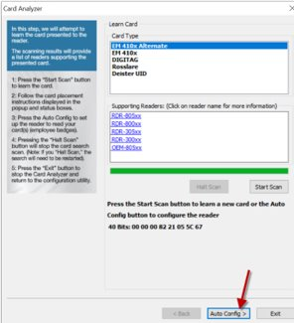

* 1. Write the configuration and once writing is complete exit pcProxConfig tool

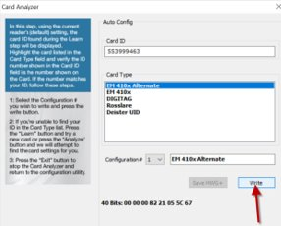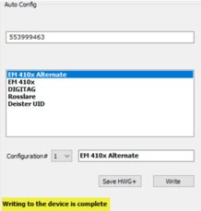

* 1. Start Notepad app and put the card on the reader. The card ID should appear in Notepad

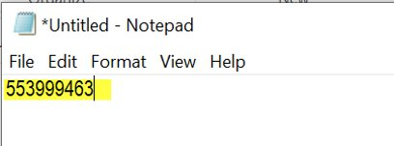

1. Remove existing badge reader and replace with RFIDeas reader using the same mounting location but route the reader cable and plug it into the Smart Op Panel.
   1. Place the sticker that was packaged with the reader to indicate where the user should swipe their badge
2. Verify the following SP settings:
   1. SP 5-113-001 – Set to 0
   2. SP 5-113-002 – Set to 0
   3. SP Mode: 5074-2 - Set to 0
   4. SP Mode: 5074-50 - Set to 0
   5. SP Mode: 5074-91 - Set to 0
3. Set the USB Device setting to ‘always connected’
   1. Enter Screen Service Mode - On Keypad Select:  Reset 8 0 6 1 8 2 # # C
   2. Select “Screen Device Settings”
   3. Scroll down and select “Screen device always-connection Setting”
   4. Set to “Active” and once back on previous screen select “Logout” in upper right.
4. Setup the Prox Card Reader settings in Screen Tools
   1. For SOP G2 devices (IM 430, MP 501, MP 4055, MP 5055, MP C406, MP C407, MP C4504, MP C4504 EX):
      1. Log into SOP Screen User Tools
      2. Scroll to Screen Device Settings
      3. Select IC Card/Bluetooth Software Settings
      4. Select IC Card Reader
      5. Select Proximity Card Reader
      6. Select Proximity Card Reader Settings
      7. Select “Auth”
      8. Select Proximity Card Reader Support Plug-in
      9. Select “Do not Use”
   2. For SOP G2.5 devices (IM C4500):
      1. From the SOP Home screen, Select “Settings”
      2. Select System Settings
      3. Select Network Interface
      4. Select External Interface Software Settings
      5. Select IC Card Reader
      6. Select Proximity Card Reader Settings
      7. Select “Auth”
      8. Select Proximity Card Reader Support Plug-in
      9. Select “Do not Use”
5. Set: User tools – Screen Features – Screen Device Settings – Screen Startup Mode – NORMAL
6. Locate and launch Web Browser NX from the APPS screen then press the Setting Menu icon (3 bar icon next to Home button) – Security Settings – Set ‘Check SSL Error’ to Do not Check
7. Enable Remote Panel Operation on all devices. This may require updates or installation of the Smart Op Panel applications or OS.
   1. Follow local processes to ensure SOP OS and applications are updated and Remote Panel Operation is enabled.