|  |  |  |  |
| --- | --- | --- | --- |
| **Print@IBM** | Bildergebnis für IBM | **Pick-Up Protocol**    **Form Updated April 2021** | **Technician Name (Printed):**  **__** |

**For GDPR compliance**, when adding any personal data (name, email, phone number) to this form, please ensure you have consent for each person. They must understand their information will be shared outside their country and with Ricoh affiliates.

**Please fill out this form in its entirety and reserve time to complete this task while onsite, before leaving IBM premises. Ricoh & IBM signatures Required** Printer information (SDM & Technician)

|  |  |
| --- | --- |
| ***Printer Deletion Protocol*** | |
| **Device - Deletion of the Data (Technician)**  **\*\*\*\*\*SELECT ONLY 1 OPTION\*\*\*\*\*** | |
| **Perform this option as priority**  * Please ensure Ricoh tech obtains Login and Password beforehand Disconnect communication cables from machine   1. Log in as Admin * 2. Press System Setting -> Administrator Tools 3. Press Next -> Next -> Erase All Memory 4. Select DoD (Department of Defense) as method for overwriting 5. Press OK 6. Press Erase -> Yes 7. Once complete, Press Exit 8. Turn Power Off and Unplug | **Perform IF Option 1 is not successful:**  **Send an email to:** [**IBM_GlobalFleetManagers@ricoh-usa.com**](mailto:IBM_GlobalFleetManagers@ricoh-usa.com) **PRIOR TO LEAVING THE SITE with the following information:**   1. Country-Site-device name and Description of the error code listed on the device 2. Add Name of Ricoh Fleet Mgr/RSDM   **Note: If the Erase All Memory screen is grayed out, please delete all extended features, reboot and retry the process again** |
| Scan and send signed completed PDF to Ricoh Global Fleet Managers with the following information included: Email Subject: "Take-back protocol Site Name"  Fleet Manager Email: [*IBM_GlobalFleetManagers@ricoh-usa.com*](mailto:IBM_GlobalFleetManagers@ricoh-usa.com)  Add Name of Ricoh Fleet Mgr/RSDM | |
| **Comments (Technician) -** Describe any issues with the removal of the device or disk DoD overwrite here. | |
|  | |

|  |
| --- |
| **Confirmation of Completion (IBM & Ricoh)** |
| **IBM Contact/**  **Escort Name IBM Signature Date _**  **Ricoh Technician**  **Name Ricoh Signature Date** |

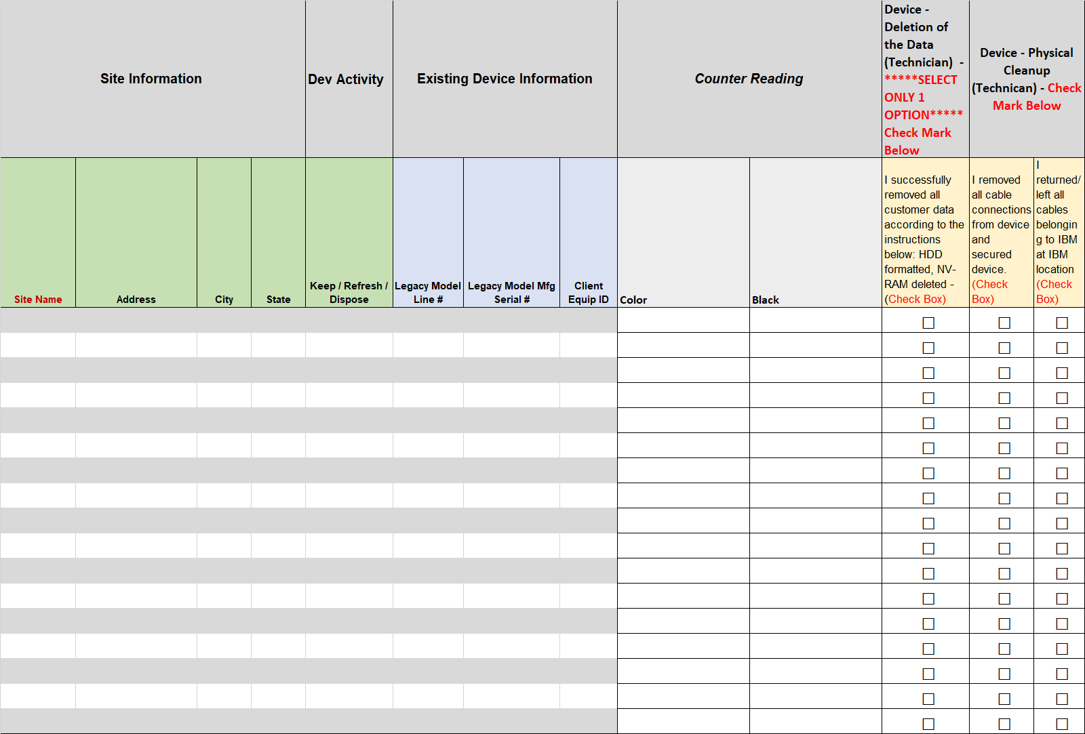

End of List