**OAuth 2.0: How to Change the Settings After Firmware Update**

After updating the firmware that supports OAuth2.0 authentication, it is required to change the settings on Web Image Monitor (WIM) to use the authentication*.

OAuth2.0 authentication is required when using SMTP servers as "smtp.office365.com" provided by Microsoft.

Please refer to the links for details.

<https://learn.microsoft.com/en-us/exchange/mail-flow-best-practices/how-to-set-up-a-multifunction-device-or-application-to-send-email-using-microsoft-365-or-office-365>

After the firmware update, please change the following added settings.

1. Select “OAuth2.0 (for Exchange Online)” in “Email Send Authentication Method.”

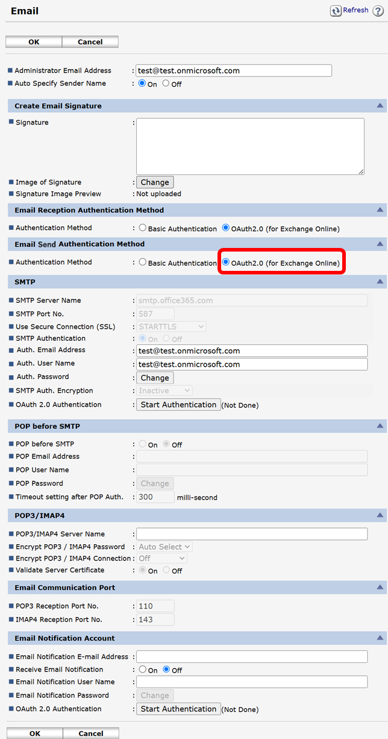

1. Enter the administrator’s Microsoft 365 e-mail address into “Auth. Email Address” in “SMTP.”

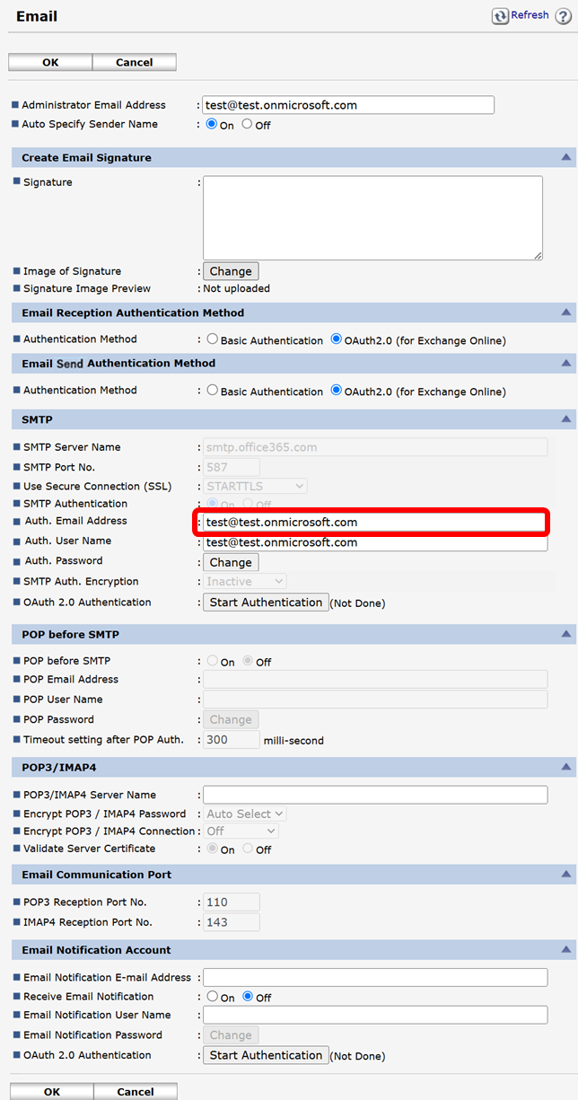

1. Enter e-mail address that is the same as the SMTP authentication e-mail address into “Auth. Username” in “SMTP.”

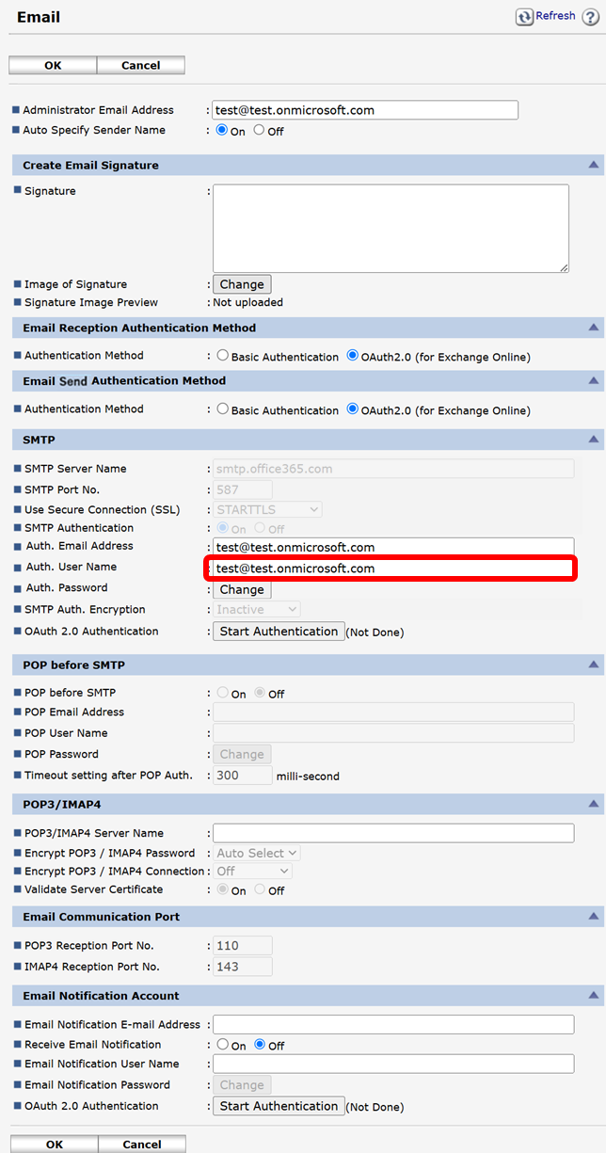

1. Click “Start Authentication” in “OAuth 2.0 Authentication” and execute the authentication in “SMTP.”

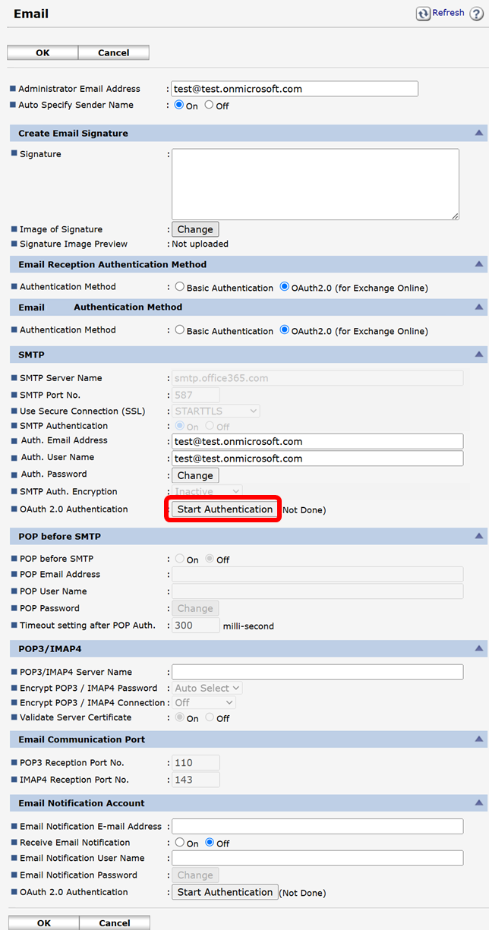

1. After the screen transition, read the description on the screen and follow the instructions.  
   (Copy the code, click “[Microsoft]” in the following screen, and open the Microsoft authentication screen to complete the operation)

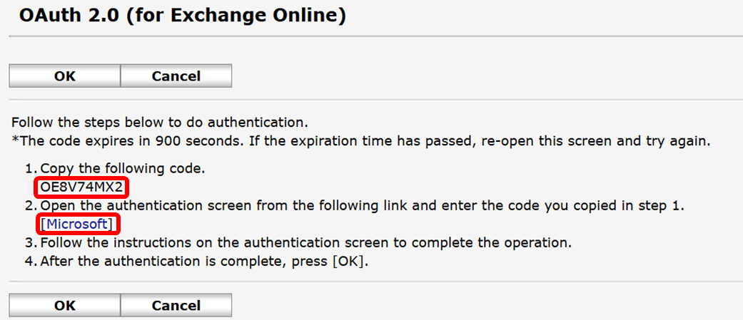

1. Execute Microsoft authentication following the instructions on the MS authentication screen*.

7-1. Enter the user code that you copied in step 5*.

*Different codes are displayed for each user who executes the authentication.

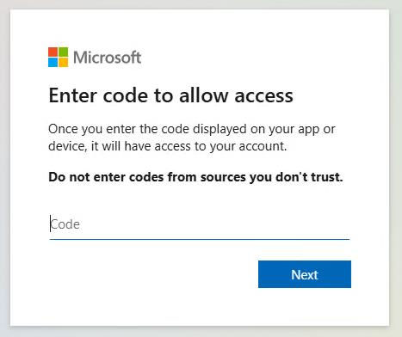

7-2. Enter Exchange Online Account and sign in

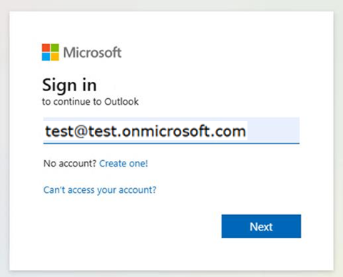

7-3. Enter Exchange Online password.

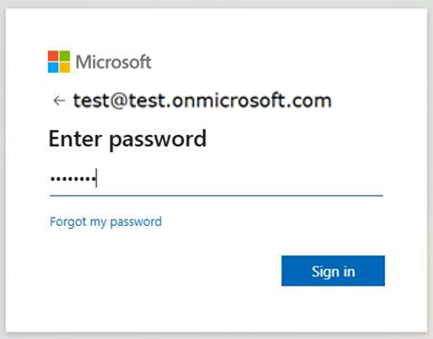

7-4. SMS code or Microsoft authentication code sent to the user’s cellphone or smartphone*.

*The picture below shows an authentication code.

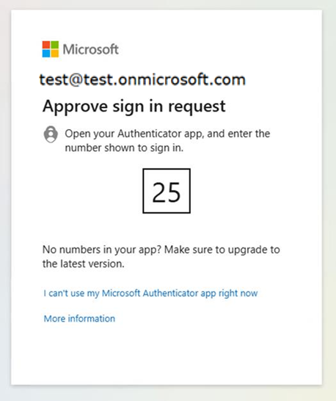

7-5. After completing authentication by the smartphone or cellphone that received the code, the following screen is shown. Follow the instructions.

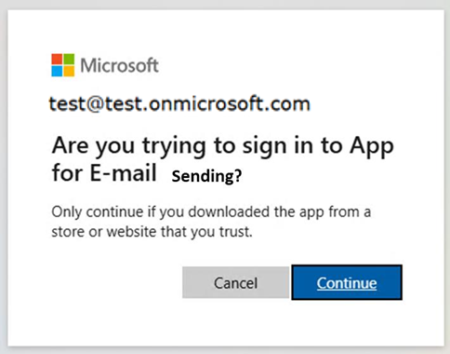

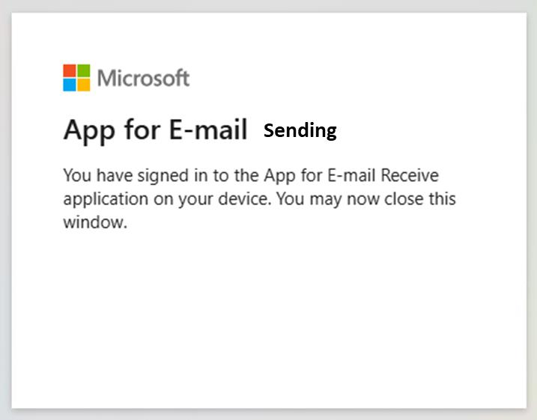

1. Close the Microsoft authentication window and click “OK” on WIM.

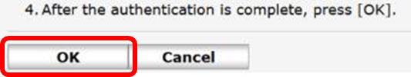

1. WIM authentication is completed.

